FICIAL INTERNATIONAL PUBLICATION OF THE ASSOCIATED LOCKSMITHS OF AMERICA, INC

2000

**Volume 46, Issue 6**

*Master Keying*

***How Do You Measure Up?***

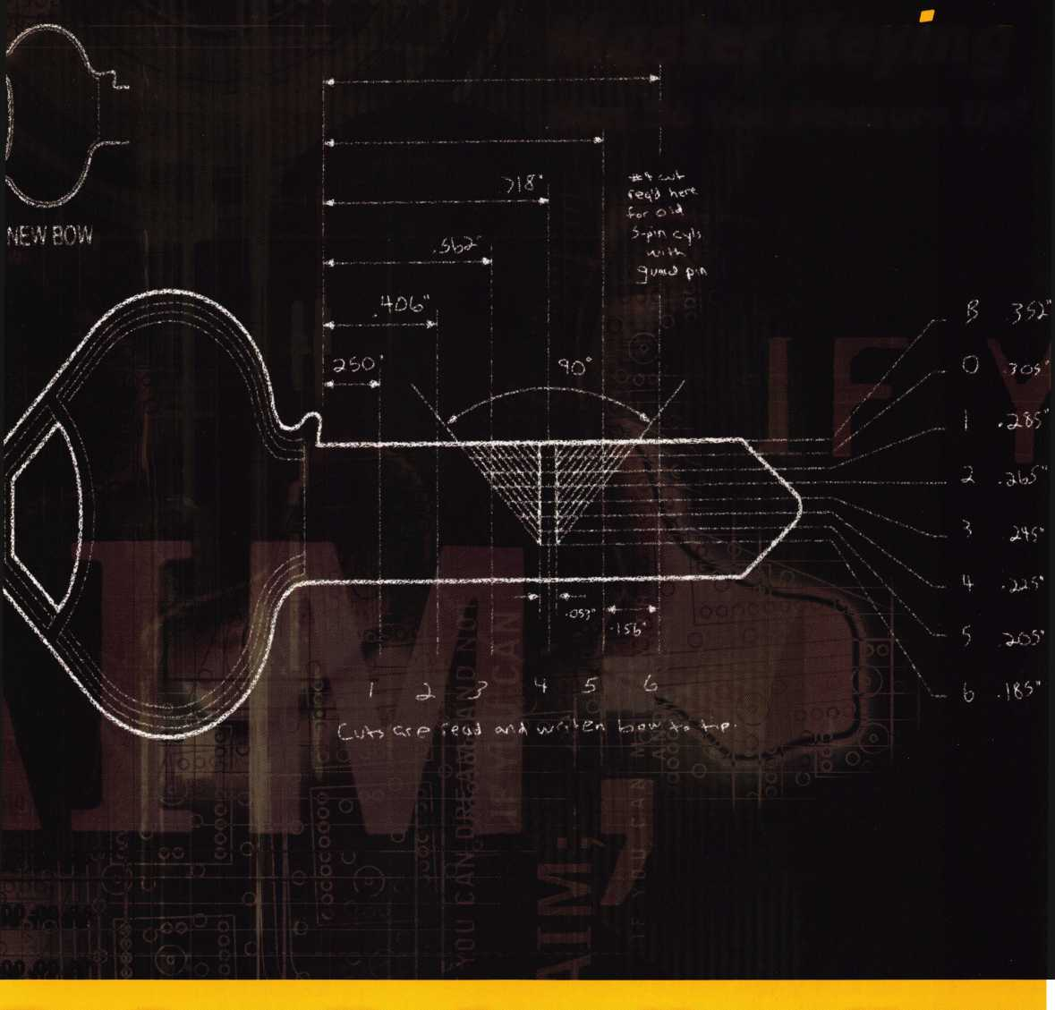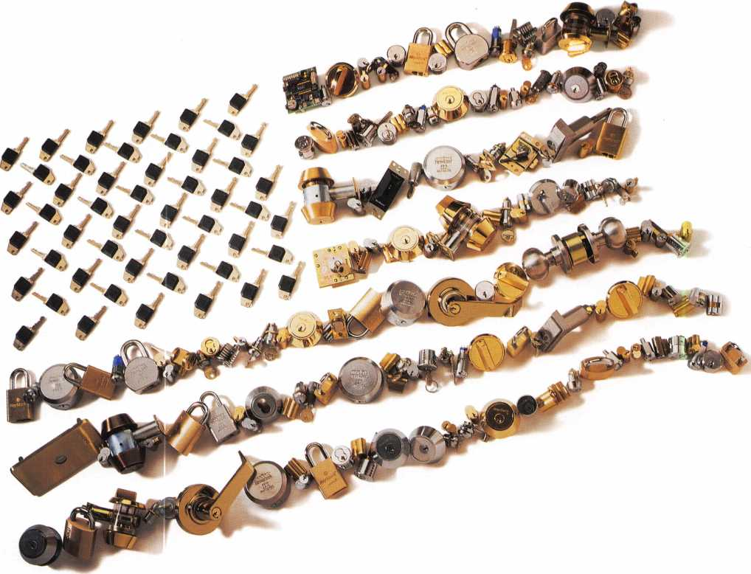

It's red, white, and blue.  
(In brass and chrome.)

Medeco® is proud to be made in the U.S.A. And we're proud of every single product we produce. With solid brass construction, hardened steel inserts, and nickel-silver keys, a Medeco product is red, white, and blue to the core. Which means you can rely on quality Medeco products to perform to your high standards. For more information, call 1-877-397-0648.

medeco

**HIGH SECURITY LOCKS**

3625 Allegheny Drive, Salem VA 24153  
[www.medeco.com](http://www.medeco.com)

Strong. Secure. Solutions. Utility patent protection Site surveys Premier quality Rim cylinders Deadbolts Vending locks Key-in-knob cylinders Power supplies Technical support OEM locks Euro cylinders Electronic training Maglocks Key control programs Components Special function cylinders Institutional security Small format interchangeable cores Camlocks Gaming locks Pick resistance Mortise cylinders Mechanical training Parking meter locks Key machines Dropbolts Pay phone locks Residential security Interchangeable core cylinders Drill resistance Commercial security Electronic access control Upgradeable keys Lever locksets Masterkeying Padlocks Retrofit cylinders Business development training Knob locksets Electric strikes Switchlocks

An ASSA ABLOY Group company

**We're saving space for you**

V '

A \L ' 0 A

✓ «

*if*

**J/Uly 2 4-3 6  
Las Vegas, NV**

^/ww.aloa.'org



n tents

June



Features

President's Journey

13

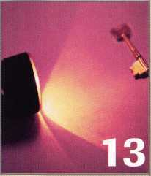

Unmasking

30

Master Keying-Planned Option

Take a look at the options involved in planning a secure master keying system.

By Don Dennis

16

Multi-Master + From DLA

Our author gives you an overview of Master Keying systems and the software used. He also explores the format of Multi-Master + from DLA.

By Sal Dulcamara, CML

18

Master Keying Corbin Russwinn Large Format Icore

Take a look at the considerations involved in writing a system for Corbin Russwin Large Format Icores. The author demonstrates the construction of a key bitting array, choice of control and the writing of a pinning chart for the system.

By Jerome V. Andrews, CML

21

ALOA 2000 Election

Candidate profiles, important information and a proxy ballot for easy return.

30

Unmasking the Master Key

Our author takes the mask off as he introduces you to the mechanics of mechanical Master Keying.

By Sal Dulcamara, CML

34

Legislative Update

By Tim McMullen

Art direction/design Phoenix Concepts 972.479.9026 ConQuest Graphixs 817.285.0003

J. KeynotesJune 2000



Technical Editor

Communications/Financial Coordinator Editorial Advisor

Advertising Sales

Contributing Editors

Contributing Authors

David Lowell, CML, CMS

[david@aloa.ioffice.com](mailto:david@aloa.ioffice.com)

Patanya Johnson

John D. Cannon, CML

[jdcannon@worldnet.att.net](mailto:jdcannon@worldnet.att.net)

Marvin Diamond

Native American Journal Co.

(706) 782-0878

[thediamonds@mindspring.com](mailto:thediamonds@mindspring.com)

Paul Chandler, CRL

Claire Cohen, CML

Sal Dulcamara, CML

Jerome V. Andrews, CML

Brian Costley, CML, CMS

Bob De Weese, CPL

Ray D’Adamo, CML

Michael A. Ferrill

James Glazier, CML

Daniel Graffeo, CRL, CMS

Wayne Gurnee, CRL

A.J. Hoffman, CML

Ken Holmlund, CRL

Ray Lusk, CML

Mark Ohno

Randy Simpson, CML

Robert Stafford, CPL

Dave Thielen, CML

Executive

Board



Additional contact information for the ALOA Board and most Keynotes authors is available through “Locksmith Search'" on the ALOA website- [www.aloa.org](http://www.aloa.org) or by contacting the ALOA office at 3003 Live Oak Street; Dallas, IX 75204; [800)532-2562;

FAX [214)827-1810; e-mail [aloa@aloa.org](mailto:aloa@aloa.org).

President

John J. Greenan, CML, CPS (773) 486-2030

Secretary

John D. Cannon, CML (703) 960-6413

Directors, Northeast

James H. Glazier, CML (301) 831-5454 John C. Magee, III

1. 845-3434 William L. Young, CML
2. ) 647-5042

Directors, Southeast

Thomas W. Tate (850) 476-4211 Donald E. Rule, CML (601) 324-2658

Directors, North Central

MarkE. Blum, CML, CPS (517) 482-5809 Tom Ripp, CRL (608) 262-3831

ALOA Professional Staff Executive Director

Operations Manager

Comptroller Accounting Assistant Government Affairs Manager

PRP/Education Manager

PRP/Education Coordinator Membership Coordinator Conventions/Meetings Manager

Charles W. Gibson, Jr., CAE [charlie@aloa.ioffice.com](mailto:charlie@aloa.ioffice.com) Mary May

[mary@aloa.ioffice.com](mailto:mary@aloa.ioffice.com) Kathy J. Romo Kathy Stokes Tim McMullen [tim@aloa.ioffice.com](mailto:tim@aloa.ioffice.com) David Lowell, CML, CMS [david@aloa.ioffice.com](mailto:david@aloa.ioffice.com) Ashley Spencer Shelly Jett LaDana T. Houser

Director, South Central

Randy L. Simpson, CML (713) 780-7026

Directors, Southwest

Gordon R. Racine, CML (719) 384-4707 John A. Ilk CRL (602) 420-2174

Director, Northwest

Scott L. Henke, CRL, CPS (907) 248-3785

Director, Associate Members

Judd Penske (800) 634-5465

Meeting Coordinator  
Chapters & Regional  
Associations Liaison

Information Systems Manager

Thom Terry

Tim McMullen [tim@aloa.ioffice.com](mailto:tim@aloa.ioffice.com) Randy McChristian



Mission Statement: The Associated Locksmiths of America, Inc. is dedicated to enhancing the professionalism, education and ethics among locksmiths and those in related sectors of the physical security industry. With approximately 10,000 members in the United States, Canada and the freeworld, ALOA is poised to help members obtain the knowledge, the strength, and the confidence to perform their role in the physical security field with pride and dignity. But it is only through active involvement and participation that ALOA can fully achieve its potential-and can help members to achieve theirs.

Policies: Keynotes® is the official publication of the Associated Locksmiths of America, Inc. (ALOA). Keynotes® acts as a moderator without approving, disapproving, or guaranteeing the validity or accuracy of any data, claim, or opinion appearing under a byline or obtained or quoted from an acknowledged source. The opinions expressed by the authors do not necessarily reflect the official views of ALOA. Also, appearance of advertisements and new products or service information does not constitute an endorsement of products or services featured by the Association. The Association does not accept responsibility for the inaccuracy of any data, claim, or opinion appearing in this publication, due to typographical errors on the part of the authors, Association staff or its agents. Editor’s Note: This publication is designed to provide accurate and authoritative information in regard to the subject matter covered. It is provided and disseminated with the understanding that the publisher is not engaged in rendering legal or other professional services. If legal advice and other expert assistance is required, the services of a competent professional should be sought.

Authors’ Payment: Payment for eligible submissions to Keynotes will be based on the following criteria: topic, time spent and past contributions. Authors who regularly submit to Keynotes are generally paid a higher rate. The latter is especially true of authors who write to fit specific editorial needs and submit said copy by Keynotes deadlines. As a general guideline: Average payment for a 750 word, business or ‘light’ technical article would be $200. Payment for a 1500 word article involving significantly higher time and research efforts would be $400.

Payment will not be offered for articles submitted by ALOA employees or members of the ALOA Board of Directors (unless material is of a technical nature), nor for articles submitted by a company that promote that company’s products or services. ALOA reserves the right not to pay for articles submitted by an individuals) that promote a particular company’s products or services.

Disclaimer: The Associated Locksmiths of America, Inc., (ALOA), reserves the right to refuse any article for any reason. Additionally, ALOA reserves the right to edit, amend or modify any article submitted for publication in order to preserve technical accuracy, clarity, fairness or grammatical correctness. ALOA will make the best efforts to notify the author of any changes. The extent of ALOA’s liability for any article or information contained therein will be a notice of correction or retraction in the next possible issue.

Keynotes® (ISSN 0277 0792) is published monthly except for the combined June/July issue by The Associated Locksmiths of America, Inc., 3003 Live Oak St., Dallas, TX 75204-6186. Telephone: (214) 827-1701; FAX (214) 827-1810; e-mail [aloa@aloa.org](mailto:aloa@aloa.org). Subscription rates for members-$15.00 per year. Second class postage paid at Dallas, Texas. POSTMASTER: Send address changes to: Keynotes, 3003 Live Oak St., Dallas, TX 75204-6186. © Copyright 1999, All rights reserved. No part of the contents may be reproduced or reprinted in any form without prior written permission of the publisher.

Trustees

Dallas Brooks

(334) 826-8990

David M. Lowell, CML, CMS

(800) 532-2562

Breck H. Camp, CML

(770) 455-6244

Edwin Toepfer, RL

(416) 225-5589

Past Presidents

1997-1999 Dallas C. Brooks 1995-1997 David Lowell, CML, CMS 1993-1995 Breck Camp, CML 1991-1993 Henry Printz, CML 1989-1991 Evelyn Wersonick CML, CPS 1987-1989 Leonard Passarello, CPL 1985-1987 Joe Jackman, CML 1983-1985 Stanley Haney, CPL 1981-1983 Louis LaGreco, CPL 1979-1981 John Kerr, RL 1977-1979 Clifford Cox, CM L 1974-1977 Charles Hetherington 1972-1974 Gene Laughridge 1970-1972 William Dutcher, RL 1968-1970 Constant Maffrey, RL 1966-1968 Harold Edelstein, RL 1964-1966 William Meacham 1962-1964 Robert Rackliffe, CPL 1960-1962 Edwin Toepfer, RL 1956-1960 Ernest Johannesen

June 2000

Keynotes

with John J. Greenan



C/D

c

CD

"D

CO

<D

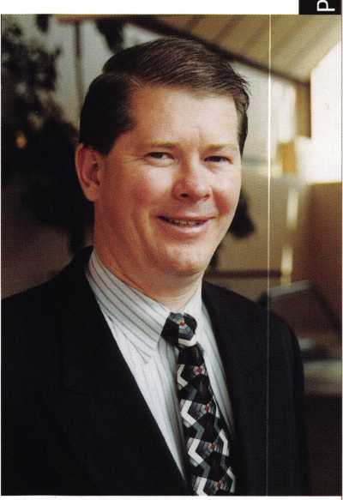

SAFETECH 2000 has come and gone. It was another week of outstanding classes from the best instructors in the industry, followed by an exhibit of leading manufacturers and suppliers with the latest in tools and products for the safe and vault industry. If you were unable to attend this year, make your plans now to be in St. Louis for next years SAFETECH.

The Friends of SAVTA Auction at the kick-off party was another huge success. Mark Miller and his group from Lockmasters really out did themselves this year. They raised more than $23,000 for SAVTA. I wish to thank Mark and all the safe technicians who participated in the auction this year. Mark has been running the Friends of SAVTA Auction for the past six years and has raised nearly $100,000 for SAVTA. If you get a chance, please thank Mark personally.

Speaking of auctions and kick-off parties, this year in Las Vegas the ALOA Scholarship Foundation will be hosting the Thursday night kick-off party.

This will be an event to remember. Dallas Brooks, the chairman of the ALOA Scholarship Foundation, has been putting together an incredible list of items for the auction at the kick-off party. This will be a live auction with the proceeds going to the ALOA Scholarship Foundation. If you are going to be in Las Vegas, be sure to attend the kick-off party.

The proxy ballots for election of ALOA officers have been mailed out to members in the Northwest region. This is the only region that we had a contested election. We will announce the result of the elections in next month’s Keynotes.

Our executive director, Charles Gibson, represented ALOA at the ELF Convention in Bulgaria. He will have articles in future issues of Keynotes covering the events there. Tim McMullen, our legislative manager, will be attending the National Association of Security and Investigative Regulators (NASIR) forum to represent ALOA’s position concerning the regulation and licensing of locksmiths.

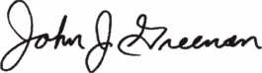

John J. Greenan, CML, CPS

June 2000

J ***Keynotes***

* Super bearing construction.
* Superior rigidity and accuracy.
* Shipped with carbide cutter.
* 2 year parts and labor warranty.
* Increased cut rates:

Laser mode 8 seconds.

Standard mode 12 seconds.

Bi Axial 6 pin 17 seconds,

* New Medeco Autoswing head option.

ULuCDOB

muHDoa

WEAR EYE PROTECTION

* Up to 800 built-in manufacturer depths and spaces.
* Works with most popular Master key systems.
* Serial port to communicate with user systems.
* Repeatable accuracy of l/1000th inch.
* Dependable heavy duty construction.
* 1 year parts and labor warranty.
* Cuts Medeco™ High Security keys with angled cuts.

The ITL 9000 was built by locksmiths — we know what you wanted so we built it. When a new lock comes out you add the space and depths immediately. No Mechanical adjustments. All sealed and prelubricated bearings.

ITL-9000

QSSOO

EMDEBB

GKBGDIDO

GOSQO

WEAR EYE PROTECTION

* Uses either 12 or 120 volts.
* All manufacturer depths and spaces built in,
* Heavy duty construction.
* 12 month warranty.
* Built in Master key System.

TOOLS LIMITED

— **Now Distributed Throughout USA, Canada & Australia** —

2639B Progressive Way • Abbotsford, BC Canada V2T6H8  
USA: 562-699-0060 • Canada: 604-852-8904 • Canada Fax: 604-852-8938 • Toll Free: 1-888-264-6627

|  |  |
| --- | --- |
| ram | ; ) LJ |
| ms]® | GJ0 |
| mm® | □□ |
| In (Mil | iSl f |

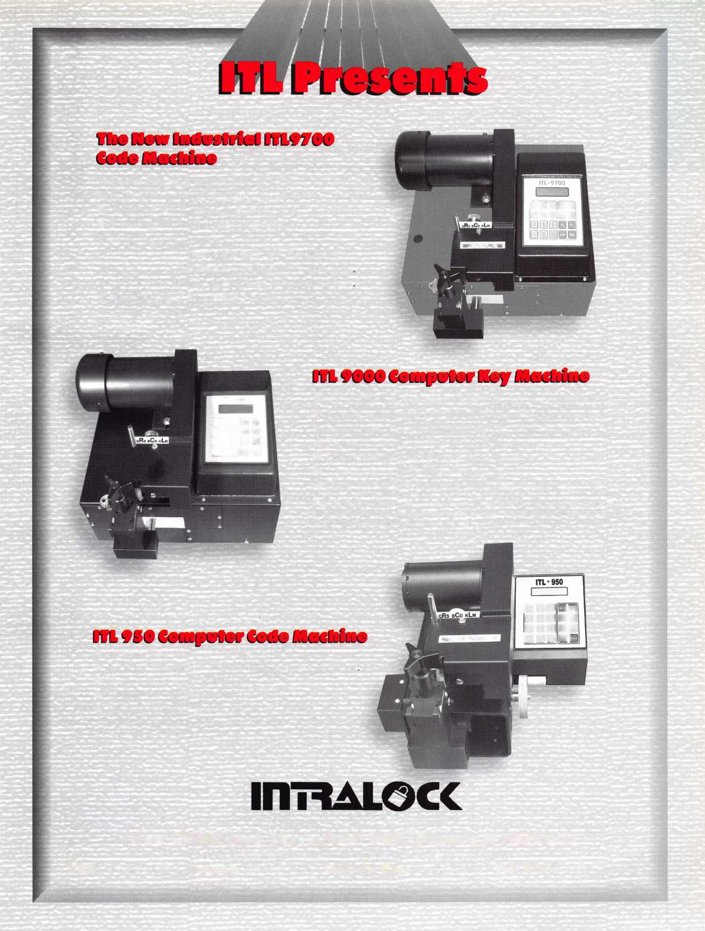

core

• Click4.com Launches $5 Million Internet Service Giveaway

Click4.com an Internet search engine that allows consumers to locate, evaluate and schedule service calls with neighborhood service businesses with just one click, is giving away $5 million worth of high-visibility listings to the first 10,000 service businesses that apply and qualify.

Click4.com provides a way for businesses such as locksmiths, contractors, remodelers, electricians and architects to attract new clients in their local area via the Internet, without the frustration of being listed among thousands of competing businesses and irrelevant links on major search engines and at the fraction of the cost of yellow pages and on-line directories. It is a fast, easy one click method for consumers to locate high-quality service businesses in their local area. Consumers will no longer have to sort through hundreds of irrelevant links or pages of stale information to find a hometown service professional. When consumers enter a zip code at Click4.com or any of its sixty websites, such as Click4Locksmiths.com, they obtain instant search results for local Click4.com business members. Results include the business’ affiliations, guarantees, experience and service hours.

Interested companies can sign up at the Click4.com Web site or by calling (877) 254-2549.

Briefs

* Akron Hardware Adds Product Lines

Akron Hardware, a wholesale distributor of Assa Abloy products, has recently added the McKinney and Securitron product line to their offering. The addition of the hinge and electronic security products round out their offering of Sargent and Arrow architectural hardware products.

Akron along with Mas Hamilton announce a joint effort to make Mas Hamilton’s line of high security, self-powered access control products available to distributors.

Elections

* Get Ready to Mark Your Ballot!

The president has called for a special membership meeting at 10:00 a.m. on June 23, 2000 at the ALOA headquarters-3003 Live Oak Street, Dallas, Texas. Ballots were mailed to members in the Northwest Region prior to June 1 and members in all other regions turn to page 21 of this issue of Keynotes for your vote-by-proxy. (Note: all ballots must be received no later than June 21, 2000 by mail/fax only to:)

Sutton Frost Cary LLP Attn: Kim D. Crawford, CPA,

Centerpoint Three 600 Six Flags Drive, Suite 600 Arlington, Texas 76011 Fax: 817-649-3202

• Marks USA Acquires Assets of Almet, Inc.

Marks USA has acquired tools and dies for the entire product line of locksets from the former Almet, Inc. MARKS intends to manufacture the Almet #1000 line of pressure cast tubular lever handle locksets in passage and privacy functions in various finishes. In addition, certain mortise lock trim will be produced and added to the MARKS line of locksets.

s $1,000 Give Away

ALOA will be giving away $1,000 per hour on

July 30, 2000 at the Security Expo, in Las Vegas,  
NV. Any and all registered attendees to the show  
will have the chance to win. There is no catch!  
Simply register and be on the show floor when  
your ticket is drawn. Good-luck and see you there!

4

***Keynotes***

June 2000



John Joyce

Kenneth B. Cecil

Gary Aratoli

* Regions

The Louisiana-Mississippi Locksmith Association, Inc. Summer Board meeting will be in New Orleans, LA at the IDN-Acme Dealer Show on June 3, 2000.

New Mexico Locksmiths Association Annual Convention will be held June 7-11, 2000 in Albuquerque, NM.

* PRP

ALOA would like to congratulate the following individuals who have recently achieved PRP designations.

CRL

Mark Akers, Torrance, CA

Charles Brasier, Plano, TX Mark Caudill, Dallas, TX Gary L. Henry, Eugene, OR Timothy Horton, Manassas, VA Michael P. Mattern, St Louis Park, MN Andrew G. Mirman, Greenvale, NY Roland M. Moulton, Nashua, NH Chris Ortiz, Richardson, TX Gary Quick, Rixeyville, VA Todd E. Rasmussen, Poison, MT Dale Rutherford, Winnipeg, CA Salvatore Scarpa, Randolph, NJ Leo Volkman, Annandale, MN Ronald Weaver, Jr., Newton, PA

CPL

Kelly M. Fuller, Las Vegas, NV Robert C. Herrington, Meadville, PA

CML

James A. Bennett, Sr., Terrytown, LA

* EXECS

Group 4 Securitas Technology Corporation recently announced John Joyce as Northeast Regional Sales Director and John Casas, Director of Government Sales.

Kenneth B. Cecil has been appointed VP of Business Development of SecuraKey.

Gary Aratoli joins the Napco West Coast Sales Team as Regional Sales Manager.

* Obituaries

ALOA bids farewell to Joseph R. Mitchell, another faithful member. Joseph a member of ALOA for 18 years, was active in local locksmith organizations and the owner of Arringtons Dekalb-Gwinnett of Atlanta. His daughter Valorie, also a member of ALOA, will continue operation of the company. We send our condolences to the family and friends of this faithful member.

WHOLESALE SERVICE ^

800-848-9790

**One Call Gets You...**

**Amsec**

**Gardall**

•

**Hayman**

**Meilink**

**Victor**

•

**Winchester**

**Plus Free Delivery  
From America's  
Largest Inventory  
of Safes.**

June 2000

Keynotes

**Upcoming**

Events



[Dept)

JUNE

I

ALOA PRP Sitting New Orleans, LA IDN-Acme, Inc Contact: W Wayne Hilliars (504)837-7315

1. 837- 7321 fax
2. 11

NMLA Annual Convention ALOA PRP Sitting Ace Classes Albuquerque, NM New Mexico Locksmith Association Contact: Steve Smith

1. 281-6777

9

**t** ALOA PRP Sitting Dallas, TX

Contact: Ashley Spencer (214)827-1701 (214) 827-1810 fax

10-11

Ace Classes Montogmery, AL Alabama Locksmiths Association Contact: Dallas Brooks (334) 826-8990

II

**fcr\** Ace Classes Lititz, PA

Contact: Ashley Spencer (800) 532-2562 ext. 30

11

**f** ALOA PRP Sitting Austin, TX Cothron s Safe & Lock Contact: James L. Hancock, CRL (512)472-6273 (512)472-4383 fax

18

ALOA PRP Sitting Lancaster, PA

NefFs Safe, Lock & Security Contact: William NefF (717) 203-4483

1. 25

INTERSCHUTZ 2000 Augsburg, Germany US Dept of Commerce Contact: Donna Peterson Hyland (609) 987-1202 (609) 987-0092 fax [info@hfusa.com](mailto:info@hfusa.com)

1. 22

ISC Expo Chicago, IL (800) 840-5602 isc.reedexpo.com

25

ALOA PRP Sitting Largo, MD

Institutional Locksmiths’ Association Contact: Philip Rovenolt (301) 645-7786 (301) 843- 9843 fax

JULY

14

ALOA PRP Sitting Dallas, TX

Contact: Ashley Spencer (214) 827-1701 (214) 827-1810 fax

24-30

ALOA 2000 Security Expo **t** PRP/STPRP Sitting **\^a** Ace Classes Las Vegas, NV Contact: Ashley Spencer (214) 827-1701

AUGUST

ii

ALOA PRP Sitting Dallas, TX

Contact: Ashley Spencer (214) 827-1701 (214) 827-1810 fax

20

ALOA PRP Sitting Ellicott, MD Clark Security Products Contact: Ron Cooling (858) 974-5273 (858) 974-5284 fax

28-31

ISC Expo New York, NY (800) 840-5602 isc.reedexpo.com

SEPTEMBER

1. 9

DHI Convention San Francisco, CA Contact: Kathy Devey (703) 222-2010

8

ALOA PRP Sitting Dallas, TX

Contact: Ashley Spencer (214) 827-1701 (214) 827-1810 fax

1. 10

TAOL 27th Annual Convention Toronto, ON Canada Contact: DonDeKuyper

(416)321-2219 (888) 272-8265

**V7„** Indicates ALOA ACE Class

6

**fr** Indicates PRP Sitting

8-10

**Csa** Ace Classes Gulf Shores, AL

Alabama Locksmith Association Contact: Dallas Brooks (334) 826-8990

10

Ace Classes Meriden, CT

Nutmeg Chapter of ALOA Contact: Roger Wechter, CPL (203) 845-8700

11-14

ASIS Convention Orlando, FL (703) 522-5800 [www.asisonline.org](http://www.asisonline.org)

17

**f** ALOA PRP Sitting Buena Park, CA Clark Security Products Contact: Ron Cooling (858)974-5273 (858) 974-5284 fax

20-24

GPLA **50+1** Convention **^** ALOA PRP Sitting Philadelphia, PA Contact: Nelson Dayton (610) 688-9188 [www.gpla.org](http://www.gpla.org)

23

Ace Classes Phoenix, AZ

Grand Canyon Chapter of ALOA Contact: John Ilk (480) 967-1876

29-OcL 1

National Trade Show & Educational Seminar Jo-Van Distributors Inc. (Toronto)

Contact: Larry

(416) 752-7249

30

ALOA PRP Sitting Kansas City, MO

Missouri-Kansas Locksmith Association Contact: Bob Turner (816) 525-5522 (816) 525- 8628 fax

OCTOBER

5-7

Lou-Miss Fall Convention Jackson, MS

Lou-Miss Locksmith Association

***Keynotes***

June 2000

13

ff ALOA PRP Sitting Dallas, TX

Contact: Ashley Spencer (214) 827-1701 (214) 827-1810 fax

13-15

SERLAC (Ta Ace Classes Jacksonville, FL Contact: James Riley (941) 294-8679

14

f/VRP Sitting Colorado Springs, CO

Central & Southern Colorado Locksmith Association Contact: Rick Dyer, CRL (719) 282-0360 (877) 694-6011 fax

23-27

Tri-Regional Show Seattle, WA

Contact: Robert Kotovic (847) 692-5940

NOVEMBER

1-5

Yankee Security Convention ^T\ Ace Classes Sturbridge, MA (800) 209-8266

10

ALOA PRP Sitting Dallas, TX

Contact: Ashley Spencer (214) 827-1701 (214) 827-1810 fax

JULY

16-22

ALOA 2001 Security Expo Baltimore, MD (800) 532-2562

Oct

15-21

Tri Regional Locksmith Conference Portland, OR

Pacific Locksmith Association Contact: Stan Hauer (503) 325-7334 Email [hauer@pacifier.com](mailto:hauer@pacifier.com) Contact: Ken Mead (503) 873-6932

2002

JULY

22-28

ALOA 2002 Security Expo Rosemont, IL (800) 532-256

DECEMBER

8

fj? ALOA PRP Sitting  
Dallas, TX

Contact: Ashley Spencer  
(214) 827-1701  
(214) 827-1810 fax

2001

FEBRUARY

3

Ace Classes  
Birmingham, AL  
Alabama Locksmith Association  
Contact: Dallas Brooks  
(334) 826-8990

MARCH

28-April1

MLANJ 2001 Annual Convention  
Ace Classes  
If PRP Sitting  
Somerset, NJ  
(973) 267-8884  
(973) 538-2248 fax  
[www.mlanj.org](http://www.mlanj.org)

5ECURITy§5

LOCK COMPANY HIP

**New** Factory Replacement Parts and Locks for Security Corporation and Kumahira Safe Co. Products

* Safe Deposit Box Locks and Parts BX, KD
* Automatic Remote Tube Systems (ARTS)
* Drive Up Systems
* Vault Doors
* Night Depositories
* Camera Systems
* Key Blanks and
* Keys Cut to Code

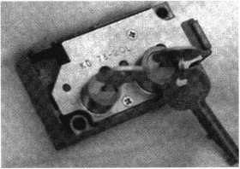

KD Series

Safe Deposit Box Locks

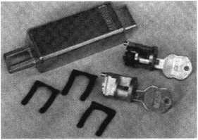

BX Series Safe Deposit Locks

1155 Chess Drive, #114 Foster City, CA 94404 Phone: (650) 525-0660 Fax: (650) 525-0444

Email:

[chaslutz@securitylockco.com](mailto:chaslutz@securitylockco.com)

SECUFtlTyS

LOCK COMPANY IP

June 2000

9

Keynotes

**Security**

Marketplace

American Door Services, Inc.

American Door Services, Inc. opened an online catalog store with secure credit card ordering and specializing in commercial door hardware. The catalog features hinges, locks, closers, stops, accessories, panic exit devices and many other items. One of the features of this site is that it offers detailed descriptions and specifications for the items listed. **American Door Services, Inc. www. commercialdoorhardware, com (888) 421-4432**

Sargent and Greenleaf, Inc.

Sargent and Greenleaf has freshened the face of an industry standard with the introduction of new dial inserts. The inserts offer a new look for the 21st century. Simpler in design, the inserts feature a cleaner, richer look, with gold lettering on black and a distinctive silver line around the edge. The new dial inserts will become the standard for both key locking and non-key locking convertible dials.

Sargent and Greenleaf, Inc.

PO Box 930

Nicholasville, KY 40340-0930 (606)883-9411

(606) 887-3226fax

Access Hardware Supply

Now available from Access Hardware Supply is Sargent’s 10 line battery operated lock. The Sargent Keypad 10 Line Cylindrical Lock is a battery-operated, self contained microprocessor controlled unit. The non-volatile solid state memory records the last 15 transactions and ensures that codes will not be lost if the batteries fail. It is programmable through the keypad with up to 100 user codes and over 1 million combinations. This unit can be programmed as a momentary unlocking device or unlocked and used as a passage unit. A remote unlocking feature is available.

Access Hardware Supply (800) 348-2263 (800) 433-8233 fax



Marks USA

Marks USA has now developed an ANSI grade one tubular deadlatch. This product was created by modifying its grade one tubular deadbolt components to accommodate a new heavy duty, grade one tubular latchbolt. The latchbolt features a stainless steel deadlocking latch nose with a 9/16” latch throw. The result is a tubular deadlatch, which is available in both conventional as well as IC core cylinder models.

Marks USA

3300 New Horizons Blvd.

Amityville, NY 11701 (631) 223-3400 (631) 223-6136fax nancy **@** marksusa. com

Master Lock

Master Lock Company now offers a complete heavy-duty hasp line with the addition of four broad application commercial hasps: a straight bar hasp (No. 730) for common flush closing door and gate applications; a 90 degree bracket hasp (No. 731) ideal for vending, warehouse and other common double-door systems; a 90 degree angle bar hasp (No. 732) for tight corner and sliding door security; and a circular two-piece hasp (No. 770) that surrounds Master Locks solid steel round padlock (No. 6270), to prevent forcible attacks. These hasps are constructed of hardened steel. Nos. 730 and 732 feature concealed mounting hardware and are designed without traditional hinge pins. All feature a corrosion resistant chrome finish.

Master hock Company P.O. Box 100367 Milwaukee, WI 33210 www. masterlock. com

Alarm Lock Systems

Alarm Lock Systems, Inc, introduces the new Trilogy Mortise Locks, DL3500 series. The DL3500 is available in Classroom Models that feature a latch bolt with 3/4” (1.91 cm) projection, or Deadbolt Models featuring both a

_A ***Keynotes***

June 2000

1” (2.55 cm) deadbolt projection and the same latch bolt projection as the Classroom Models. These locks come in four finishes including Satin Chrome, Antique Brass, Polished Brass and Polished Chrome, with additional finishes available. They also come in your choice of Trilogy lever set, or with new Regal curved handle trim. Some of the advanced features of the Mortise Lock include: 300 user codes; all models are weatherproof and operate from -20 ° to 151° F (-29° to 66° C); 40,000 event audit trail provides a printed time/date-stamped logging of all activity; and 4 programming levels and 4 user groups.

Alarm Lock (800) ALA-LOCK

Knox Company

Knox Company recently announced the introduction of an attack resistant Postal Key Keeper, designed exclusively for U.S. Postal Service use. The Knox Postal Key Keeper holds keys, access cards and other small items necessary for postal access into buildings and gated communities. The Knox Postal Key Keeper is designed to accept USPS high security modified Arrow locks and Standard Arrow locks. The keeper is now available in surface mount style and a recessed mount style will be added at a later date. Special locksmith pricing of the surface mount unit is $158 plus shipping.

Knox Company 17672 Armstrong Ave Irvine, CA 92614 (800) 332-3669 (949) 232-0482 FAX

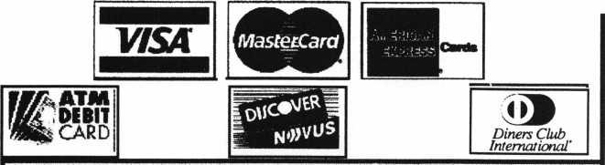

Accept Credit Cards  
and Increase Sales and Profits  
by 30% - 50%

C/^tevJ^

Through Association Benefits

These Concerns Are Eliminated

There are three reasons why people don’t accept credit cards:

1. Too expensive.
2. The paperwork hassle.
3. Inability to qualify.

Here’s how it works:

* Simply swipe or enter the credit card #.
* Enter amount of sale. No Hassle - Easy Qualifying
* Approval within seconds.
* Funds wired electronically into your local checking account within 48 hours.

Because of your association membership, nearly 100% of all retail and home based applicants

will be approved even with past credit problems.

I c“n*nH?!;v*»s|rorAf

H Receive a |x 9rdfTl Fqq

?C*e°ITcl2£S%.OI,

—F£ES'

Currently Processing Merchants Please Read

Monthly Lease To Own Set-Up Options

Special Low Discount Rate and Transaction Fee: 1.59% + 20$ Plus Monthly Statement!Customer Service Fee: $10

Package A: $29.95 Terminal Package B: $39.95 Terminal & Printer In One Deluxe Package C: $49.95 Portable Temunal/Printer/Rn Rad **Debit acess fee** Ability to Accept Visa/MC “Check Cards”

$ 10/mo. & **atm Cards ataFLAT 25$**

**Totally Eliminating the 1.59 % Rate**(All lease terms 48 months • Monthly minimum **$25)**

J I authorize Universal’s sales office to print and deposit a check in the amount of $49 (normally $125) for my application fee which covers initial materials, application processing, equipment warranty, shipping & handling, programming, installation and training.

* Fill out a check, tape here above mini form and then fax.

Fax Express Mini Form Now To 1-800-439-7773

Company Name. Contact Name _

Address. City

State-

New Aecount Set-up Options (Cheek)

Package A I—I Package B □

Deluxe Package C I—i

A subsidiary of Universal Savings Bank, FA.

| Phone

•^Signature

Best Time

Free Pin Pad Program For Currently Processing Merchants □

Marketing Office 1-800-836-4295

Universal Payment Processing Provides 24 Hour Live Customer Service.

June 2000

Keynotes

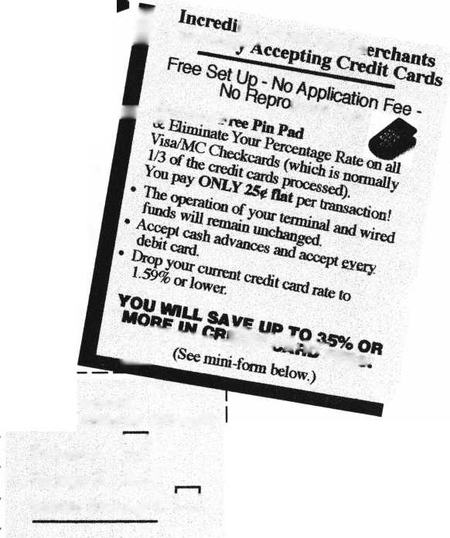

Applicants

For Membership

Dept

“ *Ihe following applicants are scheduled for clearance as members  
of ALOA The names are published for member review and comment  
prior to July 1, 2000, respectively, to ensure applicants meet standards of  
ALOAs Code of Ethics. Protests, if any, should be addressed to the  
Membership Department and must be signed. Active Membership applicants  
(A) have worked in the industry two or more years. Allied Membership  
(AL) applicants are not locksmiths, but work in a security-related field.  
Apprentice Membership (AP) applicants have worked in the industry  
less than two years. A*

|  |  |
| --- | --- |
| ARKANSAS | KANSAS |
| El Dorado | Salina |
| Janet E. Burchfield | Fred Mason |
| ARIZONA | MARYLAND |
| Glendale | New Windsor |
| Daniel R. Jacobs | Michael E. Stang CML |
| Jerry s. Hammes  CALIFORNIA  Long Beach | Nancy K. Stang  MICHIGAN |
| James D. Myers | Grand Rapids  Thomas G. Ziemer |
| San Jose | |
| Flip R. Morton | Howel  Christopher w. Wilde |
| FLORIDA | |
| Pompano Beach | MISSOURI |
| Frank D’Onofrio  INDIANA | Ballwin  Jack Bender |
| Greenwood | Saint Charles |
| Gerald R. Hayse | Donald C. Hayes, Jr. |

|  |  |
| --- | --- |
| Saint Louis | Bechtelsville |
| Dolton L. Ammons | Randy L. Mathias |
| MONTANA | Lansdale |
| Hamilton | Guy S. Huber |
| Fred L. Martin | Palmyra |
| NORTH CAROLINA | Kevin M. Reinhold |
| Banner Elk  James D. Storie | TEXAS |
|  | Dallas |
| NEW YORK | Cirilo T. Barcenas |
| Kingston  Eric Longendyke | CANADA |
| William R. Campbell | Calgary |
| William C. Landesman | Nikolay K. Nikolov |
| Penfield  Gary S. Fame |  |
| PENNSYLVANIA  Aston  William S. Williams |  |

**BE A PART OF 1.800 LOCKSMITH!  
USE THIS NUMBER IN YOUR CITY  
& OWN THE MARKET!**

We are looking for qualified locksmiths who want to expand their business

and develop themselves into one of the largest locksmith operations

in their city. You will be authorized to use our logo and name

and we will advertise for you on radio and television.

Insterested locksmiths will be able to “secure”

as large or as small a territory as they

desire. Territories will be based

on zip codes.

I



v«

**Mi®**

**[www.l800locksmith.net](http://www.l800locksmith.net)**

**Call today for more information or to sign up!**

***Keynotes***

June 2000



Master Keying - Planned Options

By Don Dennis

We have often heard that master keying is nothing more than a planned destruction of security.

It is easy to understand why, since we add so many shear line opportunities within the cylinder by the addition of master pins. It is, therefore, important to understand that there are options to be employed that will maintain certain degrees of security for systems that you create. Let’s take a quick look at why we create a planned destruction of security and then view some creative options to put some security back into the picture.

Planned Destruction

We know that master keying is not only an accepted part of the world of locksmithing, but it is a necessity in the business and corporate world. We know that electronics are gaining inroads into this area and for very good reasons. The main reason is because of the security level that is provided by the electronics. If an electronic system is programmed for three entry codes, then only these entry codes are going to work. Plain, simple, and very straightforward to understand! If, in a master key system, you want three keys to fit a 6-pin cylinder (ex. Great grand master key, master key, and a change key), you have

the creation of 61 ghost keys that could be made that will also fit this one particular cylinder. That’s right! There are 64 keys total that will fit a single cylinder in a six-pin master key system when you utilize master pins in all of the chambers. Let’s take a look by viewing one chamber at a time.

If you have six bottom pins, then you have only one key that will bring all six pins to the shear line. Let's say this key has the following cuts, 234561. When we place one master pin in the first chamber, we now have two keys that will fit the cylinder. Let's say we place a master pin with a 2-step increment in the first chamber. This means that our first key, 234561, will fit as well as another key, 434561.

Now add another master pin to the second chamber with a 4-step increment. This will give us keys with the following cuts 234561, 274561, 434561, and 474561. We now have four keys, when we may have only wanted to have two keys, to fit this particular cylinder. Two of these keys become what we term as ghost keys or keys that had no intention and no planned involvement in the system.

Jane 2000

***Keynotes***

13



When we add a master pin to the third cylinder chamber with a 2-step increment, we wind up with eight possible keys. They are 234561, 274561, 276561, 236561, 434561, 474561, 476561, and 436561. This process continues until we add a master pin to each chamber.

We began with the key cut to 234561 with master pin increments of 2,4,2 in the first three chambers respectively. Now let's finish the master pin loading by adding master pins to the last three chambers of our six-pin cylinder and look at the results. Let's make the last three chambers with the pin increments as follows: 4,2,6. This will give us bottom pins of 234561 with master pins of 2,4,2,4,2,6 being loaded on top of the bottom pins. Below are all of the possible keys that can be generated from these pins in their respective chambers.

MASTER PINS 242426

BOTTOM PINS 234561

|  |  |  |  |
| --- | --- | --- | --- |
| GMK 234561 | 236561 | 274561 | 276561 |
| 234567 | 236567 | 274567 | 276567 |
| 234581 | 236581 | 274581 | 276581 |
| 234587 | 236587 | 274587 | 276587 |
| 234961 | 236961 | 274961 | 276961 |
| 234967 | 236967 | 274967 | 276967 |
| 234981 | 236981 | 274981 | 276981 |
| 234987 | 236987 | 274987 | 276987 |
| 434561 | 436561 | 474561 | MK 476561 |
| 434567 | 436567 | 474567 | 476567 |
| 434581 | 436581 | 474581 | 476581 |
| 434587 | 436587 | 474587 | 476587 |
| 434961 | 436961 | 474961 | 476961 |
| 434967 | 436967 | 474967 | 476967 |
| 434981 | 436981 | 474981 | 476981 |
| 434987 | 436987 | 474987 | CK 476987 |

Again, we are looking at a cylinder where we want three keys to fit the cylinder (grand master key, master key, and a change key). If the grand master key has the cuts of 234561 and the master key is 476561 while the change key is 476987, there are actually 64 keys that will fit this cylinder, not just 3 keys. Another way of putting it with the proper terminology is that you have 3 keys for a six-pin cylinder and yet have an additional 61 ghost keys as possibilities.

I think you can see from the above that reckless master keying is a destructive process if a great deal of attention is not paid to what is being planned. The primary concept is to pay attention to an old adage or a rule if you like. Master keying should never employ any more master pins in a cylinder than needed to achieve the number of keys needed. There are not any parameters that will help you derive this concept except by using good common sense. There are, however, two areas of master keying that can be manipulated to provide better security. One is in how we cut the keys and the second is our selection of a system.

The Options

There are many things that can be done to improve the security found within a master key system. No matter what we do to try and put security back into the situation, we need to be up front with our customers by telling them that what they are getting is more convenience as opposed to more security. Then let them know what you intend to do to inject some security back into their situation. Here are some of your choices.

Cutting Keys:

One of the problems that is inherent to a master keyed cylinder is when someone takes a cut key and raffles the key in and out of the cylinder in short bursts. The result is like that of picking the cylinder. Sometimes the key doesn't even need the short bursts of movement but instead by simply bringing the key out of the cylinder slightly will allow the cylinder to rotate. The opening happens due to wear in the cylinder tumblers or by lifting the tumblers to a new shear line that would not normally have been used for that particular key.

Increasing the angle of the cut that is used when making the original key can lessen both of these problems. Usually, when cutting a key, we would normally employ a cutting wheel like the 14MC for the HPC 1200 machine. This would give us a cut resulting in 100 degrees. If we lessen the cut angle to 90 degrees, such as with the cutting wheel 90MC, it will create a faster reaction in the tumblers on the cut angles as the key is retracted. It simply makes the pins livelier resulting in more difficulty in raffling and making the pulling of the key out of the cylinder a much more exacting effort in finding a shear line. Yet, using the proper key offers no difficulty.

***Keynotes***

Another possibility is in the selection of your cut depths. There are areas in my business community that all utilize the same key way. I'll take an example and use a Sargent LA keyway. It would be possible to change the key way to an LC or to an RA. Let's assume that the customer doesn't want to absorb that expense. All of the buildings were built within a five-year period and supplied by the same architectural supply firm. The master systems are all different, yet changes since the original systems were installed allowed interchanges. The business managers are now very leery about master keying and future problems. There is only one way around this. You need to set up parameters for a new set of depths.

We know that anything else that the factory sends out will be keyed to factory standards. For Sargent’s depths, it means a beginning shallow cut of 0.328 followed by the next depth of 0.308 and on to the next depth of 0.288 and so forth. Look at your charts for Sargent or on your HPC 1200 card number 44. If you have a set of HPC MK. cards that are set to 0.15 increments, you will see that the Sargent card number MK44 starts with the 0.328 cut depth and is then followed by 0.15 increments. That is a 0.328 to a 0.313 to a 0.298 and so on. By simply changing the depth increments and following the rest of the rules for setting up a master key system, you will place into being new parameters that a standard factory cut Sargent key can not operate.

You can also establish your own increment standards and be totally unique. You will need to take into consideration the key broaching pattern plug chamber depths, and plug diameters that you are working with as you go. If you use an HPC 1200 machine, you can use the HPC merge card kit to make up your own cards. If you use one of the other machines that utilize micrometers, then just make a chart of your depths and go for it!

System Choice

Some of us know how to generate our own systems from scratch. Some feel more comfortable using one of the master key computer programs that is on the market. The choice of which one to use is entirely up to you. I am most familiar with the HPC choice. As long as the program will allow you to place a hold pattern on your chambers, then you have the ability to not use master pins in chosen chambers. The choice of a one-step progression or two-step progression is not of great importance. Both of these

choices offer their own unique and flexible options. It is a matter of going back to our old adage of using as few master pins as possible. Your computer program needs this versatility if you are going to offer your customer your best effort.

The best way for me to express this concept is to talk in terms of a six-pin system. This type of system will generally use all six chambers to run a progres­sion of master pinnings. What if you had a six-pin option but only used a five-pin master key system? This would leave you with one chamber that is not in the system. This one chamber can be the sixth chamber or it can be any of the other five chambers. Let me use an example.

Let's say that you decided to use a five-pin master key system on some Schlage locks that have six chambers. You could use a constant in one of the chambers to increase security. It could be any one of the chambers. You could use the last chamber or the third chamber. Your five-pin master key may have the cuts 05894. If you were to place a 5-depth pin in the sixth chamber in all of the locks in the building, your new master key would be 058945. All of your change keys and submaster keys will also end with a 5 cut in the last chamber. Just as easily would be the placing of the 5-depth pin in the third chamber of all of the locks in the building. You're master would be 055894 instead. I am using the 5-depth pin in this example so that I will not run into too many difficulties with adjacent depth cut rules. You will have to watch out for adjacent cut rules as you work toward extremes.

To go beyond the general ideas of manipulating a system to provide the best possible security would require us to delve into specific types of systems.

There is just not enough room here to even begin to cover the topic. Master keying is a art form that will take an education, if you are going to implement it to its fullest. A good course will do wonders for your capabilities. Otherwise, you will need to find every article published and start reading. Keep reading no matter what your choice and keep playing with the parameters to learn as much as possible. The ALOA convention and show are but weeks away and if you have not taken a course in master keying then this would be a good time to start. You'll not learn it all! Even the older gentlepeople of our beloved profession are still learning a thing or two about this life long pursuit of master keying.

June 2000

***Keynotes***

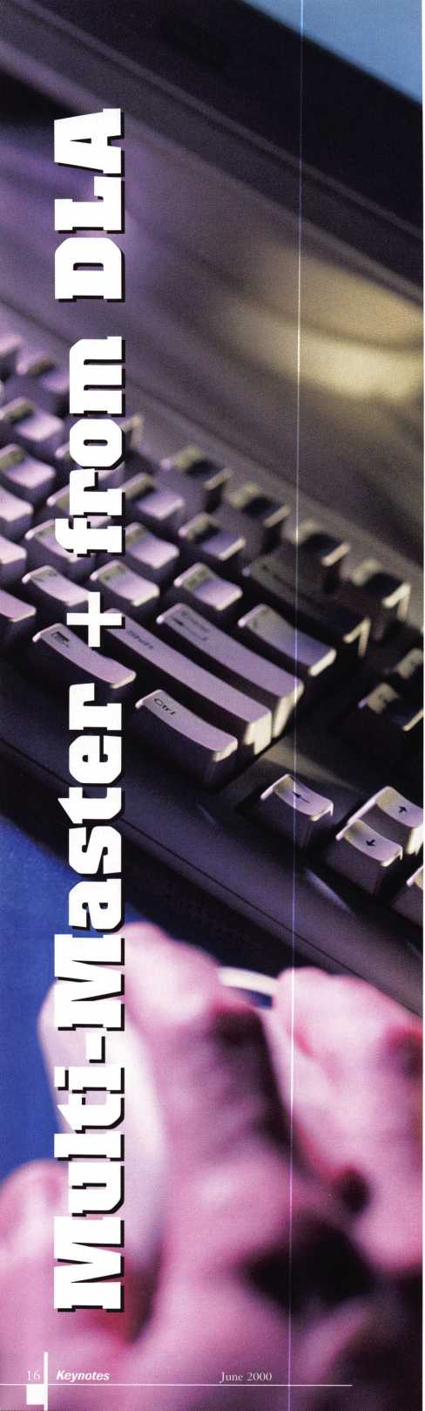

By Sal Dulcamaro, CML

O

ver the years, I’ve looked at a number of master

keying programs designed for locksmiths. If you  
are in the market for one, I suggest that you check  
out as many different programs as possible to find

which one best fits your needs. There are a number of  
rules that apply to (split pin) mechanical master keying. With a  
number of different schools of thought, certain practices are  
discouraged and certain procedures are recommended. There are  
physical consequences to master keying pin tumbler locks, and  
those who are knowledgeable realize that a price is paid for the  
convenience of a master key system. The tradeoff you make for  
that convenience is a reduction in security. A master-keyed  
cylinder is generally easier to manipulate (pick), plus certain  
unintended key combinations will operate the locks. I suggest  
you read “Unmasking the Master Key”, elsewhere in this issue,  
where I will review the “nuts and bolts” of master keying. Its  
theme has no specific bearing on the software I’m reviewing here.  
However, it is food for thought, before you even decide to offer  
master keying to your customers.

Like most other categories of software, master keying programs will tend to have certain overlapping features that are nearly identical. Most will also have unique, if somewhat less common, features that will appeal to some users but not others. Those different features often steer us to one product over another. Fortunately, to give the user some feel for the program, many of the master keying software designers have demo versions that are available free. There is a general principle that is mostly true, even though not always the case. The easier a program is for a casual user to operate, the greater effort and work you’ll find was put into writing the programming code.

Limitations of Software

I’ve always wondered (and often asked) why certain features were not included in the typical master keying program. After talking to knowledgeable people, I’ve realized that my previous statement explains the lack of those features. Writing the software becomes extremely complicated when creating nearly infinite variables for the user to input. The easier it is for us (the users), the tougher it is on them (the programmers). I have come to the conclusion that locksmiths who have the need to create medium size to very small master key systems, are probably better off drawing up the charts manually. When putting together a one or four page master key system, my problem has never been with how much time it took to write everything down. I probably could do that in not much more time than I require to turn on my computer, monitor and printer. By the time the computer booted, I’d probably have it all written. My biggest problem has been that after writing down a few dozen bittings, my handwriting starts to get a bit sloppy. I suppose that working on my penmanship would be higher on my list than finding a good master keying program.

Master keying software is probably best appreciated by locksmiths with the need to create fairly large master key systems.

When you have to progress five or six pin chambers and  
generate a list of 1000 or 4000 bittings, I can’t dispute  
the likelihood of writer’s cramp setting in before the  
hand written charts are completed. Plus, a larger system  
could benefit by a computer’s ability to identify and track  
change keys and where they are used. The distinction  
between the various players in the area of master keying  
software will often be feel and format. If you don’t  
care for the feel or format of a particular program, the  
assortment of neat features and functions may not be  
enough to sway you into buying that particular brand.

Format of Multi-Master +

Many master keying programs that I’ve seen will  
display change key bittings in a list format. When I  
first took a master keying class twenty some years ago, I  
learned the process a certain way. The format of the  
charts not only showed the page master key, but it also  
displayed various group master keys and the relationship  
of specific (intermediate level) master keys and the  
change key bittings to which they were related. It may  
be my own personal bias, but I prefer the page format of  
the charts I wrote up manually over a list format. It is  
easier for me to connect the related change key bittings  
in that format than the typical list format of many  
programs. It is that feature that caught my eye with  
Multi-Master +. Not only were the bittings grouped in  
fours and sixteens, but the block or group master key  
bittings that applied to the change keys in those groups  
were also displayed on the page. In many cases, I  
wouldn’t be using any of those mid-level master keys  
anyway, but that format was more familiar.

Something did throw me a bit at first. All the  
change key bittings were pre-labeled. Some master  
keying programs that I had previously reviewed,  
generated the bittings and allowed the user to label  
them as he or she saw fit. For a while, I was wondering  
if I would have to print out the charts and then use a  
high lighter style marker to identify which of the  
labeled bittings were in service and which weren’t.

Later I discovered that there was a separate program  
that was used to identify and track change keys that

were in use in the master key system.

There is a decent sized database of  
common brand locks for setting the specifi-  
cations for a particular system. Although  
you can’t use the program to make up a  
system for locks that have five chambers  
but master pins in just a few chambers, you  
can rearrange the key bitting array  
and sequence of progression at will.

DLA makes a related program called  
Multi-Core +, which creates master keys  
systems for IC style locks. A number of  
them (separately labeled) are essentially

Best-style format. Brands like Arrow, Eagle, Falcon, Peaks, Keymark and Schlage SFIC follow the same basic pinning rules. You do have the diverse IC systems like ASSA, Corbin and Russwin, Medeco (original and Biaxial), and Sargent. The Medeco Biaxial was somewhat impressive as that it accounted for the varying MACS (Maximum Adjacent Cut Specification) values of cut depths when having Fore or Aft pins in sequence. The same applied to the non-IC Biaxial in the Multi-Master + program. Only original style ASSA IC is in Multi-Core + . The newer style that uses build-up pins is not set up in the software.

Like much software (and other products) that I see, I wouldn’t complain if the instructions and documentation were more detailed. There appeared to be a few features or functions that weren’t explained in any great detail. Realistically, I know that you have to spend at least a few hours getting comfortable with most software anyway, but I always appreciate when the instructions make things a bit easier.

You may ultimately determine that you have no need to acquire master keying software. If you are looking for such a program, though, it might be a good idea to add DLA to your list when going comparison shopping. I’d recommend getting as many different brand demo programs as you can get, and put them through their paces. Features that appeal to some locksmiths may not appeal to you. If you know a fellow locksmith who owns a master keying program and has good working knowledge of it, you may want to check out the complete program and maybe get a first hand perspective on its ease of use. If you go with the brand that they have, you will have the advantage of a tutor to get you up to speed faster.

DLA also makes a program called Multi-Tracer designed for key control and key records management. For addional information on Mult-Master + or other related software, contact: DLA Security Systems Inc.,

629 Kimball Avenue, Westfield, NJ 07090. Phone: 908/233-7755. e-mail: [dlasec@pipeline.com](mailto:dlasec@pipeline.com). Free demos are available as a download from DLA’s website.

If you have internet access, you can find them at: ht tp: //ww w. dlaco. com

MasterLink Security Products

**ROGER ALEXANDER-TUTTLE, ALOA#5580**“...understanding the needs of locksmiths...”

Mortise/Rim/Knob Cylinders • Storefront Door Hardware  
Cabinet Locks • Chain • Key Blanks • Padlocks • Pins ...and more

Local: (954) 730.9669 • Toll Free: (877) 347.9669  
Fax: (954) 486.0575

e-mail: [masterlink@mindspring.com](mailto:masterlink@mindspring.com)

3863 NW 19th Street, Lauderdale Lakes, FL 33311

June 2000

Keynotes

**Master Keying CORBIN RUSSWIN LargeFormat ICoreJ**

**By Jerome V. Andrews, CML**

**This article assumes knowledge of master keying, including the development of an expansion specification and the techniques for writing a bitting \list. The concern here will be the essential considerations involved in writing a system for Corbin Russwin Large Format ICores. We Will demonstrate construction of a key bitting array, choice of a control and the writing of a pinning chart for the system. Doing the bitting list is up to you.**

**Radiused  
Blade Bottom**

First Cut

**Flat Blade  
Bottom**

First Cut

**Flat Blade I Bottom**

First Cut

|  |  |  |  |
| --- | --- | --- | --- |
|  | X Class Keyways  27 Series, including 28 and 29 57 Series |  | |
| .333”^^ | 67 Series, including 68 and 69 77 Series, including 78 and 79 97, 99, AR, BR, BL | Only X Class | |
|  |  | has slot or | |
|  | Z Class Keyways   1. Series   60 | um hi  /s | IUI IlfcJdU  K Y\ |
| - / | 70  L Series  and most restricted keyways |  | V |

Figure 1

|  |  |
| --- | --- |
| Keyway | Bitting Class |
| D Series | DH Class |
| H Series | DH Class |
| N Series | N Class |
| 981,982, 983 | 981 Class |
| Russwin restricted | DH Class |

.197”

for

X Class

i i

r-H

|  |  |
| --- | --- |
| Keyway | Bitting Class |
| 752 | 752 |
| 252, 852 | 852 |
| A Series | A Class |
| G | 852 Class |

i

**<j)OQOOO**

.250”

^ for aii others

**Spacing Difference**

**X Class is .197” to the first cut, while Z Class and all Russwin are .250”. The difference, .053”, is the depth of the slot in the plug head. Interchangeable core and cylinders for master ring CK4200 and UT5200 Series locks have a thinner plug head with no slot.**

18 I ***Keynotes***

June 2000



The Corbin line began with Doen, Corbin & Company in 1849 in New Britain, CT., and evolved into P. & F. Corbin, with Corbin Cabinet Lock being spun off. Russwin began as the Stanley, Russell & Company in 1839, and developed into Russell and Erwin, which was shortened to Russwin. The two came together in 1902 under the umbrella of the American Hardware Corporation. With a few exceptions, both tradenames and product lines were maintained distinctly until the brand merger in 1993.

Both companies antedate the Civil War and were

In an orderly and thorough manner, the Corbin Russwin Cylinder Manual presents current and discontinued key bitting specifications and the tumbler dimensions for all the increment systems. The Corbin Russwin Cylinder Manual is essential for servicing these products. If you do not have a copy, contact your Corbin Russwin distributor and obtain one. Certain cylinder configurations, such as master ring and ICore, have special rules. All thein- formation required will be found in the Cylinder Manual. The latest printing is the 6th edition.

Figure 2

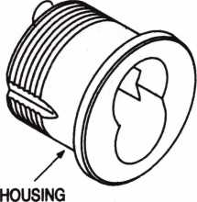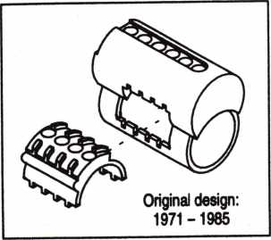

7-pin core adds a single  
shear line chamber  
at the rear

PLUG

RETAINER

CONTROL LUG

CONTROL

SLEEVE

SPRING COVER

1C SPRINGS

TOP PINS

BUILD-UP PINS (control chambers only)

MASTER PINS (as required)  
BOTTOM PINS

^ SHELL

PLUG (.509*)

manufacturing pin tumbler mechanisms before their union. Thus, there is a complex array of keyway families, key bitting specifications and other mechanical considerations.

Whether one writes a new system or extends an existing one, the first step is to determine the key bitting class and increment system. For Corbin Russwin, a key "bitting class" is a group of key sections with associated key bitting specifications and certain common characteristics, such as blade height and radius or nonradius surfaces. Figure 1 summarizes the major key bitting classes.

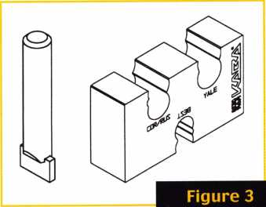

continued on page 25 June 2000 ***Keynotes***

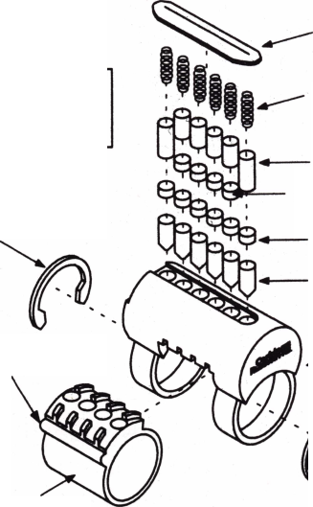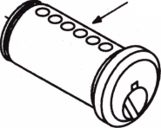

“If you want to study for the CPS test,

you **need** this **book.**

Without that book, I wouldn’t have my certification.”

-Dennis Johnson, CPS  
Aurora, Illinois

"Mike's new book is very  
consistent with the study  
information required to pass the  
SAVTA/ALOA CPS certification  
test I wouldn't have passed  
without it. A tremendous  
resource for today  
and tomorrow..."

-John T. Grist, CML, CPS

North Georgia Security

"The Safe Technicians Reference Manual by Mike Oehlert ranks among the best technical reference and learning aids you will find in the safe and vault industry. It contains page after page of essential information and easily understood illustrations. Besides answering most of the questions commonly asked by technicians new to the field, Mike has also included plenty of information experienced technicians will find useful."

-Ken Dunckel Pacifica, California

—►Over 600 Illustrations.-*—

320 pages. Only $135.

What are you waiting for?

To order, call 800-532-2562. Allow 3 weeks for delivery.

All major credit cards accepted; or make check payable to ALOA.

The Safe

Technicians  
Reference Manual

First Edition

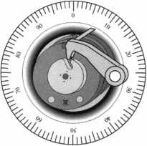

20 I

Keynotes

June 2000

Associated Locksmiths of America, Inc.

FOR MEETING OF MEMBERS

Dear ALOA Members:

The Associated Locksmiths of America, Inc. (ALOA) bylaws designate that the Secretary of the Association, Directors from the Northeast, South Central and Northwest Regions shall be elected in even-numbered years, and that the Director from the Associate Region shall also be elected in even-numbered years. The Bylaws allow voting by proxy, a procedure that will allow all members to participate in the election of their respected officers. A proxy allows you to authorize someone to vote for you at a meeting.

The President has called a special membership meeting at 10:00am June 23, 2000 at ALOA Headquarters, 3003 Live Oak Street, Dallas, TX. The purpose of this meeting is to elect the Secretary and Directors for the associa­tion.



The ballot is in the form of a proxy, prepared for you to give specific instruction to the holder of the proxy.

This will ensure that your vote is counted exactly as you desire. You must provide your name and member number, as well as, date and sign the form. Failure to properly complete the proxy may result in your ballot being invalid.

Although the election for Secretary, Northeast Regional Director, South Central Regional Director and Associate Member Director are uncontested races, you may still vote. A sample proxy is provided for this purpose.

Please vote for Secretary and your representative Director. DO NOT vote for the associate member Director UNLESS you are the employee who is the designated representative to vote on behalf of the Associate member (check with the ALOA Headquarters if you are unsure who your designated representative is). Write-in candi­dates are not allowed and there will be no one "running from the floor" at this special meeting of the member­ship. The President and Directors from the North Central, Southeast and Southwest are elected in odd num­bered years, and therefore do not appear on this ballot.

Please mail or fax the proxy as soon as possible. In order for your vote to count, the holder of your proxy must be present at the meeting and have the properly completed proxy with her. This means that your ballot must be received no later than June 21, 2000. You do not have to designate Kim D. Crawford, CPA as your proxy. You may give your proxy to anyone else, but they must attend the special membership meeting on June 23, 2000 with your signed and dated proxy in hand.

Please participate in the future of your association!

Sincerely,

ASSOCIATE LOCKSMITHS OF AMERICA, INC.

JohnJ. Greenan, CML/CPS President

June 2000

***Keynotes* 121**

SECRETARY



John D. Cannon, CML

John is currently serving his third term as the Secretary of ALOA, after serving five years as the Northeast Vice  
President of ALOA and as a Director prior to that. At various times, he has held the Chairmanship of the Education,  
Publications, Finance, and Personnel Committees, as well as being Vice Chairman of many other committees. He has  
also served as a member of the SAVTA Board of Directors and Chairman of the SAVTA Education Committee. Prior to  
his service with ALOA, he was the President of the Locksmiths’ Association of the Washington, DC Area, as well as  
Chairman of the Washington D.C. ALOA Chapter #5. Cannon is the owner of Locks Unlimited, Inc. in Alexandria VA,  
and also manufactures specialty tools for the safe and vault industry. For several years John has instructed safe deposit  
box lock classes for ALOA, SAVTA and many other regional associations.

DIRECTOR-SOUTH CENTRAL

Randy L. Simpson, CML

Randy has been a locksmith since 1973 and an ALOA member since 1985. He’s served as director of ALOAs board,  
chair of Public Relations and a member of the Bylaws and Legislation committees. He’s also had articles published in  
Keynotes and is the proprietor of Baker’s Safe and Lock Co., Inc.

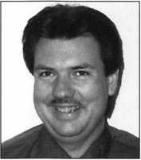

DIRECTOR-NORTHWEST

Michael Elsberry, CRL

Michael began his locksmithing experience growing up in a family lock and key business. After graduating in  
1982, he attended classes in business, computer science and music. His first job was as a software specialist for an  
Apple Computer Center. His first experience owning a locksmith business came in 1984, when he purchased a posi-  
tion in Emergency Locksmiths in Portland, Ore. In 1986, he was hired by HPC, Inc, of Chicago to lead the IlPCSoft  
Division of HPC and develop the line of software and hardware (Codemax) to enhance the way locksmiths work. In  
1990, he was hired by Medeco Security Locks, Inc. to work in their marketing department. Michael was credited with  
the development of Custom Coining on locksmith keyway programs, the universal key machine, the Patriot Program  
and the 2X business development system. In 1995, he purchased A & E Safe and Alarm Company, a locksmith and  
security company in Oregon. From 1995 to 1997, he continued working with Medeco and the 2X program, using his

personal experience as a business owner to enhance the program. In 1998, he resigned from Medeco to spend full time efforts growing his  
own company. When he purchased A & E, it had revenues of $590,000 and nine employees. The name now is A & E Security and Electronic  
Solutions. It is Oregon’s fifth largest alarm company and arguably one of the states largest locksmithing companies.

Michael is a member of the Pacific Locksmith Association, ALOA, National Burglar and Fire Alarm Association and sits on councils for Sentrol Life Safety Corporation, Security Associates, Inc. and holds a CRL from ALOA and Electrician General Journeyman Certification in Oregon and Washington.

The majority of his career has been spent on the betterment of the locksmith and security industry. His firm has become a teaching location for many security company owners to find better ways to grow and manage a company.

His goal for ALOA is to focus efforts on increasing membership to as many working locksmiths as possible, the development of an appren­ticeship training program and state conducted education for the development of CRL, CPL and CML certification. Michael believes the train­ing and development of employees will become the deciding factor for the survival of our industry.

PHOTO

NOT

AVAILABLE

Scott Henke, CRL, CPS

Scott, a lifelong Alaskan and a second-generation locksmith, has been a member of ALOA since 1982. He cur-  
rently serves on the ALOA Board as Northwest Director and on the Strategic Planning Committee. In 1998, he was  
appointed to serve on the Audit Committee. Scott attended his first ALOA Convention in 1982, where he earned his  
CRL certification. A member of Safe and Vault Technicians Association (SAVTA) since 1988, he earned his Certified  
Professional Safetech (CPS) certification during its first offering in 1994. He currently serves on the Advisory Board  
for Security Solutions. In addition, as a member of Northwest Locksmiths Association (NWLA), he gained NWLA cer-  
tification in 1983. His other memberships include the following: National Safeman’s Organization, (NSO), National  
Independent Bank Equipment & Systems Association (NIBSEA), Pacific Locksmith Association (PLA), and American  
Society for Industrial Security (ASIS).

As President and CEO, Scott is leading his family’s business, Action Security, Inc., in an increasingly diverse security market. He oversees com-  
pany-wide operations of Alaska’s largest and most sophisticated security provider. Established in 1963, Action has four locations located  
throughout Alaska, an inventory of one million dollars, a staff of 50 employees and 30 service vehicles. His duties include overseeing five dif-  
ferent operations: a banking division; a contract hardware division; an electronic division; a retail security division and a wholesale division.

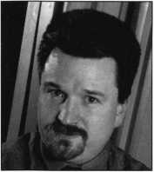

Keynotes

June 2000

He is also responsible for maintaining Action’s relationships with over 250 manufacturers and maintaining its franchise agreements with Sensormatic Electronics Corporation and LeFebure Bank Products; recently acquired by Mosler, Inc.

Scott has a long history of successfully training new employees with the essential and esoteric skills required in the highly technical secu­rity industry Deeply involved in community professional and trade organizations for many years, he has received numerous tokens of appre­ciation and recognition. Scott has avidly supported and promoted ALOA since the beginning of his career, he is a member of the President’s Club, and has sponsored over 25 ALOA members. He is supportive of the governance policy and believes the current ALOA board is making a difference.

Based on his interest to pursue the advancement of the industry and to contribute to its long range plans, Scott’s goals for ALOA include; increasing consumer awareness; expanding education opportunities; promoting professional business training and establishing the industry as an indispensable primary channel in furnishing security products and services. Scott believes he has still much to offer ALOA and its mem­bers and he would appreciate the opportunity to continue to serve on the board and make a positive contribution to the industry.

DIRECTOR-NORTHEAST

Peter Sarailian, CRL

Pete has been a locksmith since 1974 and an ALOA member since 1976. He’s served as Treasurer of the New Jersey  
Master Locksmith Association from 1994 until present, and was the president of that organization in 1987. He is the  
sole proprietor of Pete’s Lock and Key Service located in Fort Lee, New Jersey.

John C. Magee, II

Jack Magee is a third generation locksmith and owner of J.C. Magee’s Lock and Safe. Currently, he is President of  
the Greater Philadelphia Locksmith Association and an active member of the Garden State Chapter of ALOA. He has  
been an ALOA member for eight years, and on the Board of Directors since 1998. His family has actively participated  
in ALOA since 1956, when his grandfather was a charter member.

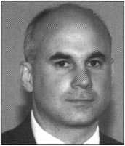

William L. Young, CML

Bill is currently a Northeast Director of ALOA. He has been an ALOA member since 1987 and a SAVTA member  
since 1989. Bill began his locksmithing career at the age of 13 and continued in the trade to put himself through col-  
lege. After earning a Bachelor of Science Degree in Business Administration from Mars Hill College (N.C.) in 1982, he  
worked as service manager for Best Access Systems of Philadelphia. In 1983, Bill went to work for A1 Security Center  
in Malvern, PA and bought the business in 1985. Bill has been consistently active in the Greater Philadelphia  
Locksmith Association (GPLA) since 1985 and has served as secretary, vice-president, president and board chairman.  
He is currently on the board of directors.

DIRECTOR-ASSOCIATE

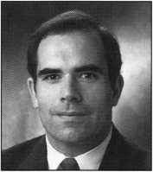

Joey Dalessio

Joey Dalessio began his career as a locksmith for the family business, Artery Lock Service, Inc. in Medford, MA  
in 1973. In 1984, he became National Sales Manager for Don-lo Mfg. located in Sterling, MA. From 1991 through  
1999, Joey worked at Medeco Security Locks as, National Sales Manager, Vice-President of Worldwide Sales and the  
General Manager of the Door Security Division. At present, Joey serves as the program manager with Security  
Solutions of Mustang, OK. Joey brings a wealth of practical experience from the service, sales and marketing fields  
through the corporate management offices and in business development.

| 23

June 2000

Keynotes

ASSOCIATED LOCKSMITHS OF AMERICA, INC.

OFFICIAL PROXY FOR MEETING OF MEMBERS

The undersigned, being the Associated Locksmiths of America, Inc. (ALOA) member indicated below, hereby appoints Kim D. Crawford, CPA the proxies and true and lawful attorneys of the undersigned to attend the meeting of the Membership of ALOA to be held at 3003 Live Oak Street, Dallas TX 75204 on June 23, 2000 at 10:00am or any adjournment thereof, and to vote on behalf of said ALOA Member as designated below:

FOR THE OFFICE OF SECRETARY) - VOTE FOR ONE (1) ONLY (Eligible to vote: Active, Apprentice, Retired, Life and Associate members):

□ John D. Cannon, CML

FOR THE OFFICE OF NORTHEAST REGION DIRECTOR - VOTE FOR THREE (3) ONLY (Eligible to vote: Active, Apprentice, Retired, Life and Associate members who's business address is in Connecticut, Delaware, District of Columbia, Kentucky, Maine, Maryland, Massachusetts, New Hampshire, New Jersey, New York, Ohio, Pennsylvania, Rhode Island, Vermont, Virginia, West Virginia, Belgium, Bulgaria, Denmark, England, Estonia, Finland, France, Germany, Great Britain, Holland, Iceland, Ireland, Italy, Latvia, Norway, Spain, Sweden, Switzerland, APO New York):

* John C. (Jack) Magee, III □ William L. Young, CML
* Peter Sarailian, CRL

FOR THE OFFICE OF NORTHWEST REGION DIRECTOR - VOTE FOR ONE (1) ONLY (Eligible to vote: Active, Apprentice, Retired, Life and Associate members who's business address is in Alaska, Idaho, Montana, Oregon, Washington, Wyoming, China, Japan, Korea, Macao, Taiwan, APO San Francisco):

□ Michael Elsberry, CRL □ Scott Henke, CRL, CPS

FOR THE OFFICE OF SOUTH CENTRAL REGION DIRECTOR - VOTE FOR ONE (1) ONLY (Eligible to vote: Active, Apprentice, Retired, Life and Associate members who's business address is in Arkansas, Kansas, Louisiana, Missouri, Oklahoma, Texas, Chile, Columbia, Ecuador, El Salvador, Guatemala, Mexico, Panama, Peru):

□ Randy Simpson, CML

FOR THE OFFICE OF ASSOCIATE MEMBER DIRECTOR - VOTE FOR ONE (1) ONLY (Eligible to vote: Employee who is the des­ignated representative to vote on behalf of the Associate Member):

□ Joey G. Dalessio

**Print/type Name of ALOA Member**

Member Number

**Member Signature** **Date**

This proxy must be signed and dated with member number to be considered valid. It must be **received no later than June 21**, **2000** and mailed/faxed only to:

Sutton Frost Cary LLP  
Attn: Kim D. Crawford, CPA  
Centerpoint Three

600 Six Flags Drive, Suite 600, Arlington, TX 76011  
Fax: 817-649-3202

**241 *Keynotes***

June 2000

Step 1. Start with a standard key bitting array and removethe forbidden cuts.

CTR 3 1 4 2 5 6

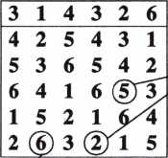

Unique control cuts must be removed from the KBA.

#6 cut cannot be used with a #1 in the control.

Step 2. Write remaining progressives in ovals.

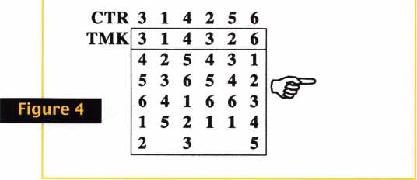

Corbin Russwin ICore physical details

Two styles of core were manufactured. See exploded view, figure 2. All cores are meant to be top loaded and chambers closed with a brass spring cover. The spring cover is flattened into the channel on the top of the core. It is possible to end load cores with a follower, but in any quantity, top load­ing is preferable.

Improper staking of cores causes them to be distorted out-of-round. When staking any brand, the core should be supported at the waist to prevent damage. Corbin Russwin does not provide a staking fixture. However, a Kaba Peaks #6840-00-3540 fixture has a cavity to support Corbin Russwin cores. Also, an ICore mortise or rim cylinder hous­ing can be modified by slicing off the top to reveal the spring cover, and then place a vise to provide staking support. Spring covers can be obtained through distribution. Part numbers for spring covers and other components can be found in the Cylinder Manual.

Writing an example system in System 70

Writing a key system for Corbin Russwin ICore is essentially the same as writing any Corbin Russwin system. Once the key bitting class and increment system is determined, you proceed in the usual way. However, there are two considerations peculiar to ICore.

First, the control key will have two cuts unique to itself. This will reduce the keying capacity. Second, with regard to pinning, because there are two plug diameters and various increment systems, there is no "magic number" to add to a control

Chambers 2, 3, 4 & 5 are control chambers

Figure 5

U_U

n

6

□

Rznznzn

5

rrjTTi

4Z1Z6

k/lTlJ

n

6

D

H

3

LU

1

MZMZM

zm

i

TO

UUU-LL

n

2

u

n

H

R

5

complete pin stacks for constants

|  |  |  |  |  |  |  |  |  |  |  |  |
| --- | --- | --- | --- | --- | --- | --- | --- | --- | --- | --- | --- |
| 3 |  | n  l |  | n  4 |  | n  3 |  | n  '2 |  | A  6 |  |
| k |  | y |  | Li |  | L1. |  | y |  | u |  |

June 2000

Keynotes

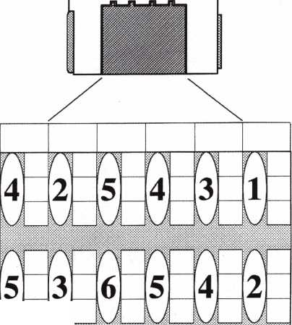

bitting in Corbin Russwin cores. Buildup pins, used in the four control chambers, are named algebraically, that is, with plus (+), minus (-) and zero (0) values. Many locksmiths actually find this easier to do than the pin stack calculations for Small Format ICore.

This example is for Z or DH Class System 70. If you wish to glance ahead to figure 10, you'll find the information that will be required to cut keys and pin cores.

Figure 6

.247"  
top pin

deep  
operating  
cut minus  
shallow  
cut

shallow

operating

cut



Figure 7

J

261 Keynotes

For conventional cores the control chambers are 2, 3, 4, and 5. Chambers 1 and 6 are standard single shear line chambers in which the TMK and control have identical bittings. In 7-pin cores, chambers 1, 6 and 7 are single shear line chambers.

The TMK and the control (CTR) differ in two places within the four control chambers. The rule is: Make the control key shallower than the TMK in one of the control positions, and deeper than the TMK in another of the control positions. The

|  |  |  |
| --- | --- | --- |
| top pin equals control bitting | CTR = 4 TMK = 4  CK = 6 | 4 |
| control minus the deep cut | \  CM  i |
| deep operating cut minus shallow cut |  | CM |
| shallow  operating  cut |  | 4 |

non-control chambers 1 and 6

-j i-

control chambers  
2 through 5

Figure 8

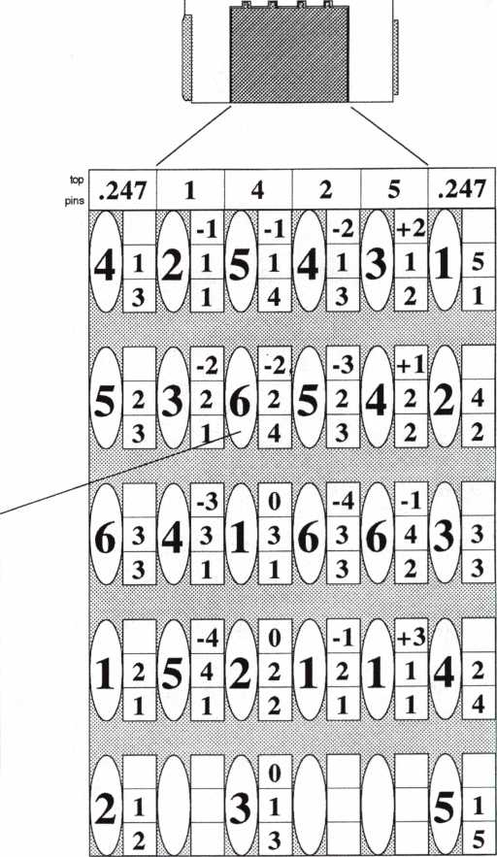

complete pin stacks for constants

FYTWW1

i

1

U

-i

3

June 2000



two bittings unique to the control must be removed from the progression columns of the key bitting array.

For System 70 specifications, there is one additional rule: Do not use a #1 cut in the control key in any of the control positions, 2 through 5. This rule does not apply to Pre-system 70 keying.

We begin as we would with any master key system, by writing a suitable top master, control key and key bitting array, as in figure 3. Notice that the TMK and control are identical, except for the two unique cuts, the #2 cut in position 4 and the #5 cut in position 5. This is the factory rule for the relationship between the control and the TMK.

Note also that I have deliberately violated the rule about a #1 cut in the control in position 2. I want you to see the consequences of violating the rule.

The next step is to remove the offending progressives from the key bitting array. The unique control cuts are removed. Also, the #6 cut must be removed in position 2 because it is incompatible with the #1 cut on the control key. This is because there is no minus five (-5) buildup pin in System 70. This will be a bit clearer later.

Corbin Russwin Z and DH Class - System 70

Applies to these keyway s:

70 59A2 59B2

59C1

S9C2

59D1

59D2

D1thru D4

HI thru H8 not published

LI thru L4 for security reasons

and restricted keyways

Code Card

CX6A

for HPC 1200CM  
Code Machine

1. .22r % .21 r
2. .199"

N '

Cuts are read and written bow to tip.

Pin Lengths (1993 Consolidation)

|  |  |  |
| --- | --- | --- |
| 4 | 09' Diameter Pli | 9 |
| Bottom Pins | Build-Up Pins | 1C Top Pins |
| 1 .160" | -4 .051" | 1 .192’ |
| 2 .189" | -3 .080" | 2 .163" |
| 3 .21 r | -2 .107" | 3 .135” |
| 4 .245" | -1 .135’ | 4 .107" |
| 5 .273" | 0 .163’ | 5 .080" |
| 6 .301" | +1 .192" | 6 .080’ |
|  | +2 .218’ |  |
|  | +3 .247" | For non-control |
|  | +4 .275" | chambers |
|  | +5 .303" | use .247" |

Figure 9

.056" .084” .112" . 140-

Standard Tumbler Spring

1C Tumbler Spring

Standard Top Pin

Spool Top Pin

Top Pin, PL5000 Padlock

Top Pin to Block Master Ring

1. Pin Spring Cover, brass
2. Pin Spring Cover, brass
3. Pin Spring Cover, brass
4. Pin spring Cover, stainless
5. Pin spring Cover, stainless

|  |  |
| --- | --- |
| Bottom Pins | Build-Up Pins |
| 1 .203" | -4 .030" |
| 2 .231" | -3 .058" |
| 3 .260" | -2 .087" |
| 4 .288” | ■1 .114’ |
| 5 .316’ | 0 .142" |
| 6 .344" | +1 .171" |
|  | +2 .198” |
|  | +3 .226" |
|  | +4 .253" |
|  | +5 .282” |

217F42-2

217F44-2

217F43-2

314F88-7

Pin Stack Calculations

Figure 6 summarizes  
the calculations for  
control and non-control  
positions.The non-  
control chambers, 1  
and 6, are treated in  
the usual manner. The  
factory uses a universal  
top pin in these two  
chambers.

In the control  
positions, 2 through 5,  
calculate the bottom pin  
and master pin in the

normal manner. The bottom pin equals

the shallow operating cut. The master pin equals  
the difference between the deep and shallow  
operating cuts.

inTirr

_2 4 2 2 4

A\JA\JA

PT'ntf;

***6l4lll6A***

Ui 11 1

-4 o -i 77nr

1 2 5,4 2 2 1 2 l i 4 2  
1 2 1 1. 4

complete pin stacks for constants

nmWW

3 1 4^3 2_6

uJLuTuAuJLljaLl

**x**

Figure 10

Figure 11

|  |  |  |  |  |  |  |  |  |  |  |  |  |
| --- | --- | --- | --- | --- | --- | --- | --- | --- | --- | --- | --- | --- |
| 247 | | 192 | | 107 | | 163 | | 80 | | 247 | | • |
|  |  | n | 135 | n | 135 | n | 107 | n | 218 | A |  |  |
| 4 | 28 | 2 | 28 | 5 | 28 | 4 | 28 | 3 | 28 | i | 140 |  |
| a | 217 | B | 160 | y | 245 | y | 317 | y | 189 | A | 160 |  |
| A |  | A | 107 | r\ | 107 | m | 80 | a | 192 | A |  |  |
| 5 | 28 | 3 | 28 | 6 | 28 | 5 | 28 | 4 | 28 | 2, | 140 |  |
| y | 217 | y | 160 |  | 245 |  | 317 | A | 189 | 0 | 189 |  |
| A |  | A | 135 | A | 135 | pi | 107 | A | 218 | B |  |  |
| 6 | 84 | 4 | 84 | 1  i JL i | 84 | 6 | 84 |  | 112 | 3, | 84 |  |
| a | 217 | y | 160 | y | 160 |  | 217 | / | 189 | A | 217 |  |
| m |  | A | 51 | m | 163 | s | 135 | a | 247 | A |  |  |
| 1 | 28 | 5 | 112 | 2 | 56 | 1 | 56 | 1 | 28 | 4 | 56 |  |
| A | 160 | y | 160 | y | 189 | y | 160 | B | 160 | y | 245 |  |
| A |  | pi |  | ri | 163 | H |  | A |  | A |  |  |
| 2 | 28 |  |  | 3 | 20 | j |  | i |  | 5 | 28 |  |
| L k | 189 | y |  | y | 217 | y |  | y |  | y | 273 |  |

complete pin stacks for constants

|  |  |  |  |  |  |  |  |  |  |  |  |
| --- | --- | --- | --- | --- | --- | --- | --- | --- | --- | --- | --- |
| n | 247 | n | 192 | n | 107 | H | 163 |  | 80 | n | 247 |
| 3 |  | i | 163 | 4' | 163 | 3 | 135 | '2' | 80 | 6 |  |
| ky | 217 | y | 160 | u | j 245 | ixl | 217 | A | 189 | u | 301 |

June 2000

Keynotes

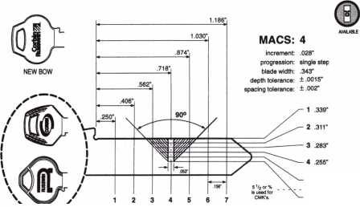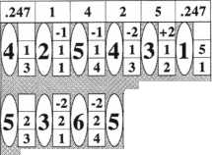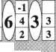

The calculation of the buildup pin is algebraic. The bottom pin and master pin together equal the deep cut. You add whatever you must to that value to get the control value. For example, if the deep cut (same as the bottom pin and master pin together) is 4 and the control cut is 4, you add a zero (0) buildup pin. 4 + 0 = 4. Or, if the deep cut is 6 and the control is 2, you add a minus four (-4) buildup pin. 6 + ( -4 ) = 2. If the deep cut is 2 and the control

is 5, you add a plus three (+3) buildup pin. 2 + 3 = 5. The size of the top pin of the control chambers is the same as control bitting in that chamber.

Determining pin length and key bitting specifications

Figure 8 is an example of the kind of indispensable information that is to be found in the Corbin Russwin Cylinder Manual. This page displays the data required for Z Class System 70. Key bitting specifications

Its True

Marray has developed the first  
screwless door loop.

Standard 18” length. Can be ordered in cus­tom lengths

Plastic base stops shorts and pro­tects wires

Screwless base and cap means you drill two 1/2 inch diameter holes, pop the base into the hole, wire your system and snap on your covers. Simple as 1, 2, 3.

**Here’s the best part We are giving away a**

FREE SAMPLE TO THE FIRST 1 **OO** CALLERS WHO MEN­TION THIS ADD. **A $**14.40WHOLESALE PRICE VALUE.

CALL TODAY, IT’S FREE!!

1-800-500-1449

Marray *enterprises, inc.*

**At Marray,** we’re not **just** modifiers, we’re Master Hardware Modifiers™  
**1128 Walsh Ave., Santa Clara, CA 95050. [www.marray.com](http://www.marray.com)**

Aluminum ma­terial means true anodizing.

No off color powder coat­ing or painting

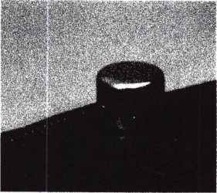

28

are given, as well as the pin lengths for both plug diameters.

Determining the actual pin lengths

Consulting page 62 of the Cylinder Manual, we determine the actual lengths of the pins. The Cylinder Manual lists actual pin lengths for each particular key bitting class. For this example, the example is Z Class System 70 with a .509" diameter plug. As the data on page 62 of the 6th edition of the Cylinder Manual indicates, the #1 bottom pin is 0.160" in length.

There are several ways to handle the issue of translation of pin sizes to pin lengths. One is to make a second pinning chart with the pin lengths in it. Another is to make a dedicated pin kit for the specification and use it whenever it is needed. Using a LAB or original pin kits make translation unnecessary, however, some locksmiths have reported that the print kit lids is rather small.

Figure 9 is the pinning chart in figure 7 with the actual pin lengths rather than the size numbers. Any core in the system can be pinned from this chart. To use this pinning chart, use the bitting of the lowest level key that must operate the core. For example, suppose the required change key is cut 645441. Find each cut in the large oval and drop in the pins listed in the boxes just to the right of the oval.

Blank forms for writing pinning charts can be obtained by sending a #10 SASE to the author, Jerome Andrews IDN - Hardware Sales, Cleveland, 7711 Brookpark Rd., Parma, OH 44129.

Keynotes

June 2000

Heed Tools? Think LockmastersL

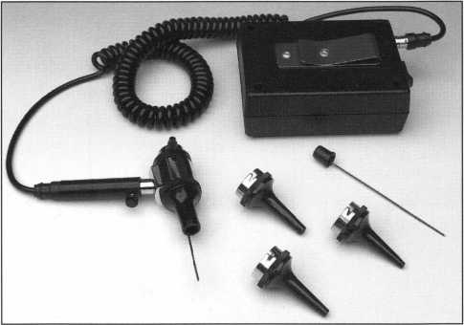

Professional Otoscope

Now here is the ultimate in otoscopes! The battery pack is powered by three C cell batteries, includes a belt clip for convenience and is backed by a lifetime warranty. Also included is the otoscope head with two pin depressors for reading wafers and decoding keyways. This otoscope also comes with a durable carrying case.

LKM2051PRO $145.00

Imp-Grip™ Impressioning Pliers

Unlike conventional locking pliers, the Imp-Grip has been remachined to lock onto a key blank, providing a secure hold for more effective impressioning and filing.

LT1005 $29.00

5" length

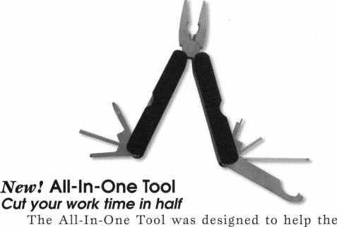

professional locksmith **rekev all standard door locks** quickly and easily such as Lori Cylinders, Adams Rite Locks, Knob Retainers, Adjust Door Closers, Auto Caps, Russ./Corb. Hardware, Baldwin Hardware, Jackson Crossbar, Schlage D-Bolts, Medeco Cap Screws, etc.

Includes: Regular Pliers, Needle Nose Pliers, Wire Cutters, Small Straight Set-Screw, Philips Driver, 1/8 Hex Key, 3/32 Hex Key, Spanner Wrench, Knob Retainer Tool, and Long 5/64 Hex.

LKM1008 $55.00

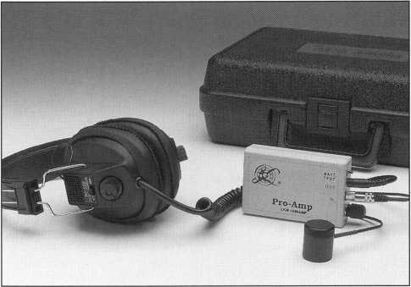

Pro-Amp™ Audio Amplifier

Our top-of-the-line audio amplifier offers a discrimi-  
nating filter system. You can tune out distracting noises  
and hone in on the signals you are listening for. This unit  
is sensitive enough to “hear” time locks, distinguish the  
difference between fly pick-up and wheel rotation. The  
Pro-Amp has all the features desired by professional safe  
and vault technicians.

Set Includes: Filtered Amplifier, Powerful Magnetic  
Microphone, Professional Quality Headphones, 9-Volt  
Battery, and Sturdy Carrying Case.

LKM1036AMP $235.00

REG. PRICE $275.00 SALE PRICE

New! N.G.S. Diagnostic Tester

The N.G.S. Tester for Ford,

Mercury, Lincoln 1996-2000 with  
PATS 1 & 2. The N.G.S. Locksmith  
kit includes everything needed for  
full PATS programming:

* N.G.S. Control Unit
* Vehicle Interface Module (VIM)
* N.G.S. Service Card & Diagnostic Card
* Complete Instruction Manual which  
  provides step-by-step instructions for  
  reprogramming.
* Hanger & Storage Case
* N.G.S. OBDII Adapter
* 10 Transponder Keys - #Hco H72PT

($85 Dealer Price)

You can use N.G.S. PATS programming to:

* Reprogram or replace lost keys
* Add extra keys
* Create spare keys

NGS $1,995.00

All N.G.S. Updates Available!

**To order, call Lockmasters® at 1-800-654-0637.**

Fax: 859-885-1731 • Email: [salesinfo@lockmasters.com](mailto:salesinfo@lockmasters.com)

June 2000

Keynotes

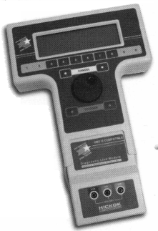

by Sal Dulcamaro, CML

Unmasking **the Master**

•■CVV/'

***mm***

In this article, I will explain the mechanics of (split pin) mechanical master keying. I will show how one can decipher the master key bitting and an assortment of intended and unintended consequences of master keying. The more information available about the tumblers and operating keys, the faster and easier the technique used to unmask (or reveal) what the master key will be. Some techniques I have learned from others over the years, while others I have developed on my own. It is my intent to call attention to certain basic realities of master keying. These are generally known by most locksmiths who have been schooled in the fundamentals of master keying, but not necessarily obvious to all locksmiths who create master key systems. Methods of labeling master (and change) keys and the terminology of the process may vary, but the inherent mechanical operation does not.

The basic operation of a pin tumbler lock cylinder involves the interaction of pin shaped tumblers within a series of pin chambers that begin at the top of the outer component (or shell) and continue in line downward to the inner component (or plug). In each chamber there are typically three parts: a tumbler spring (at the top), a top pin or driver (in the middle) and a bottom pin at the bottom of the stack. In a standard (non-IC, non-master keyed) pin tumbler cylinder, there should be no more than two pins per chamber. The cuts of a correct key should raise the pin stacks sufficiently so that the point where the top and bottom pins split will all line up at the top surface of the plug (shear line) simultaneously.

Within the manufacturer’s machining tolerances, such a lock cylinder will open with just one key cut pat­tern. A key that has cuts of different heights (outside the accepted tolerances of the lock) will not allow the pins to split at the shear line, and will not be able to open the lock.

The Mechanics of Master Keying

The mechanics will vary between locks with

different types of tumblers. The overall concept will  
be similar. Here, I am specifically explaining about  
pin tumbler locks. Many of these principles will be  
identical to most (although not all) other types of  
tumbler based locks.

Most knowledgeable locksmiths realize that master key systems are created primarily for convenience. In a facility or building, many individuals need unique access to specific areas (other individual’s keys will not operate their locks), while others of greater authority need access to overlapping (or all) areas. Master keying is sometimes the only practical option. The other possible option is to give people in authority copies of all the individual keys that open the individual locks. In a facility with ten doors, ten individuals would each have his/her own key that would only open one of the ten. The person who needed access to all ten doors would have ten keys. With such a small number of doors, it is already apparent how inconvenient it is to have ten additional keys on one’s key ring. Imagine a building with one hundred or one thousand doors. I think you get the picture.

Earlier, I explained how a standard pin tumbler cylinder will only open with one key cut pattern. Having one key, then, allows access to just one area.

As a result, the use of standard coded cylinders requires the possession of larger numbers of keys to gain a higher level of access in the facility. The more convenient setup would be to have locks that could be opened by unique individual user keys, and (at the same time) special high level access keys. In that situation, the individual users would not be able to open other locks with their (one door specific) keys, but the high level person could open all the differently coded doors with just one key. That is effectively the definition of master keyed locks.

A standard pin tumbler lock cylinder would need another split point in order to have more than one key cut pattern open the same lock. This requires the addition of a third pin to the chamber previously limited to two pins. The actual size of a master key system will depend on the number of increments possible per chamber in combination with the number of chambers that contain a third pin. My point in this article is not to show you how to create a master key system, so I won’t go into any further detail about the capacity or design of a master key system. I will explain how you can use the rules of master keying to unmask the identity of the highest level master key (TMK-Top Master Key), when you don’t have that key.

Keynotes

June 2000



Decoding the Pin Tumbler Cylinder

When you have a non-master keyed pin tumbler cylinder, it is possible to decode the key combination by disassembling the cylinder and removing the bottom pins. By measuring the lengths of the bottom pins, you can compare the dimensions with the pin length specifications of that particular brand lock and convert those values to the direct digit bitting code. Since there is only one possible key cut combination, the pin pattern you find will coincide with the bitting of the one and only operating key cut pattern. When you start out with a master keyed pin tumbler cylinder and have no operating keys (individual change key or any level master key), the decoding process will involve a certain level of trial and error. Every chamber with a master pin will have two possible cut depths for that chamber position. With no operating keys available, you can’t be certain as to which depth coincides with the master key and which coincides with the change key. To minimize confusion, I will just make up a sample pinning pattern for a lock cylinder and go through the steps involved in finding the master key.

I will start out with the bottom and master pin combination for my sample lock. I will pretend it to be a five pin Schlage pin tumbler lock, but you could subsitute other brands with ten size increments with the same results. The pin combination is as follows.

Chamber Positions: 1 2 3 4 5

Master Pins: 2 4 4 4 4

Bottom Pins: 2 3 0 1 2

If you don’t already know it, here is how you determine the possible key cut depths for a pin chamber containing a bottom pin and a master pin. This determination will be chamber by chamber.

The size of the bottom pin will always determine the depth of the shallower of the two possible cuts. The total combined value of adding the bottom pin size and the master pin above it will indicate the cut depth of the deeper of the two possible cuts for that chamber position. In the first chamber, the #2 bottom pin indicates a shallow cut depth of 2.

Adding the #2 bottom pin and the #2 master pin, totals 4, which would be the deeper cut depth for that position. So either a #2 or #4 cut depth will cause a split at the shear line in chamber #1. You can do the math yourself, if you wish, but I will list the shallow and deep cut values possible with the bottom and master pin patterns shown above.

Chamber Positions: 1 2 3 4 5

Shallow Cut: 2 3 0 1 2

Deep Cut: 4 7 4 5 6

There is no rule that the shallow or deep cut is normally for the change key or Top Master Key (TMK). Any permutation of those two sets of cuts could be the TMK. I will list all the possible permutations with that set of numbers. One on the list will have to be the TMK.

The total will come to 32 possible key cut patterns. You can figure that by raising the number 2 to the nth power, with n equalling the number of chambers with three pins. That is 2 to the 5th power or: 2x2x2x2x2. If you had problems in school with math, this might not make a lot of sense to you. You don’t need to know how I determined that there would be 32 possible key cut patterns, so I will list all 32 here for you to see.

1) 23012 2) 23016 3) 23052

4) 23056 5) 23412 6) 23416

7) 23452 8) 23456 9) 27012

10) 27016 11) 27052 12) 27056

13) 27412 14) 27416 15) 27452

16) 27456 17) 43012 18) 43016

19) 43052 20) 43056 21) 43412

22) 43416 23) 43452 24) 43456

25) 47012 26) 47016 27) 47052

28) 47056 29) 47412 30) 47416

31) 47452 32) 47456

You might be surprised if you thought that only two key cut patterns would operate the lock cylinder. After all, it may have been designed as a two level master key system with only a Top Master Key being issued and every other issued key being a specific change key that would not open any other lock cylinder than its own. On this list, one key bitting is the change key for the specific cylinder decoded, and one is the Top Master Key. The remaining 30 key bittings listed are for theoretical mid-level master keys. Some of these master keys could operate groups of lock cylinders operated by as few as only 4 different change keys (on the low end) to as many as 256 different change keys. At this point, we would have no way of telling which was which. Every combination is still a possible candidate for the TMK.

To identify the TMK, it could be necessary to cut all 32 keys listed. If you didn’t disassemble any more lock cylinders, you could try each of the 32 keys in some other lock within the same master key system. Every key that didn’t open the next lock cylinder would be either the specific change key for the cylinder decoded or a master key at a level lower than the Top Master Key. All the keys that opened the other cylinder would remain as possible candidates for the TMK, although only one of them could actually be it. You would have to approach another lock

June 2000

Keynotes

cylinder and again test all the keys that were not eliminated by the previous cylinder. By a process of elimination, you would ultimately get down to only one key that would not be locked out by any cylinder within the master key system. That key would be the TMK. As you can see, this method can be somewhat tedious and time consuming, but that is the price for not having any additional information. If you had only one cylinder that had its specific change key available for you, it would be a piece of cake.

In Like Flynn

It is amazing how one additional piece of information can make a somewhat complicated process, virtually effortless. I’m going to stick with the cylinder already decoded, but this time I’ll pretend that I had the operating change key for the cylinder. Here is the cut pattern for the change key: 43052. Go back and look at the listing of the shallow and deep cut possibilities in each of the five chambers. Chamber by chamber, we will compare the shallow and deep choices to the known values of the change key cuts. We see whether the change key cut is the shallow or deep cut listed for that chamber position. By a very simple process of elimination, the cut depth that doesn’t belong to the change key, must be the TMK cut depth.

It is important that the key be the specific change key for the cylinder decoded. If it is just a key that works the cylinder, it could very well be some mid-level master key. In that case, we probably wouldn’t be much further ahead than if we had no key at all. Presuming we have the change key, here is the process. The choices for the first chamber are 2 or 4. The change key cut is 4, so the TMK cut must be 2. In the second chamber, the choices are 3 or 7. The change key is 3, so the TMK cut has to be 7. For chamber #3, it is either 0 or 4. The change key cut of 0 dictates that the TMK cut is 4. The fourth chamber has a choice between 1 and 5. The change key is 5, making the TMK cut 1. For the final chamber, the possible cuts are either 2 or 6. The change key uses the 2 cut, so the last cut of the TMK must be 6. The Top Master Key has to be: 27416. If you look at the list of 32 possible cut combinations, you will find both the change key combination and the TMK.

The remaining 30 are mid-level master keys.

It may be surprising to a lot of locksmiths, but the combination of a master keyed lock cylinder and its specific change key are all that is needed to unmask the identity of the TMK. Every lock cylinder in the system has the same potential for revealing the identity of the Top Master Key. Although nobody

ever gave me a step by step process, as I have just done, I was clued into the basic concept by locksmiths from whom I learned master keying. I discovered another method of decoding the TMK without disassembly of the lock cylinder on my own, by deductive reasoning. For all I know, I may be the only one who knows this method. If I could figure it out on my own, it is possible that someone else followed the same trail of logic to the identical conclusion. Well either way, if I was the only one who knew it before I wrote this article, I’m definitely not the only one who knows it any more. You all appear to be in on the secret now.

Decoding the TMK Without Disassembly

They say that necessity is the mother of invention. To find the master key, I would typically use the process just mentioned. I would write down the change key cuts, decode the bottom and master pins, identify the shallow and deep cut possibilities and choose the cut value that didn’t belong to the change key. It’s a very simple and straighforward way to find the identity of the master key. I had an interesting situation. Somebody brought me a group of Master brand padlocks that were master keyed. Each padlock had its individual change key, but the master key that would open all the locks had been lost. These were not rekeyable padlocks, and I didn’t really want to have to drill out the rivets and take everything apart.

I set them aside since I didn’t have any spare time to mess with the locks at that moment. It must have been more than a year later that I pulled them back out, had a brainstorm and figured a way to decipher the master key without disassembly. I will explain the essential process in relation to the lock cylinder I’ve been using as an example for this entire article.

Because this process doesn’t require disassembly, we will start out only with the known value of the change key. That was already determined to be 43052. We already know the master key cuts too, but we will only use them to confirm the process. Otherwise, I’ll act as if they are unknown. To start out, I don’t necessarily know if every chamber has master pins, but the process should confirm that. I know in every chamber that has master pins that the change key cut will work and some other value is currently unknown. I set up the process so that I could recut test keys repeatedly to minimize the actual numbers of key blanks wasted in the process.

I will potenially have to waste one less key blank than the number of pin chambers in the lock. For a five pin lock, no more than four key blanks should be wasted. Here it goes.

Keynotes

June 2000

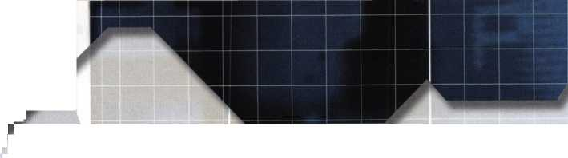

I know for a fact that a key with the first four cuts Deing: 4305_ will allow the pins in those four chambers to iplit at the shear line. The next part will depend on the verson who created the master key system. If he or she bllowed typical master keying conventions, the system vill use two step increments. That means that an odd lumber for the change key (in that chamber position) vould indicate an odd number for the master key. The ;ame applies to even numbers. An even depth for the :hange key means an even depth for the master key. iince I will use all the change key cuts for the first four positions, the only chamber that won’t be certain to have fins splitting at the shear line will be the fifth chamber.

This change key has 2 as its fifth cut. I would then itart with the shallowest even number which is 0. My key vould then be cut as follows: 43050. We already know :hat 0 is not the master key cut, but if we tried such a cey in the cylinder, it wouldn’t turn. Going deeper in ncrements of two, so we could reuse the same key over igain, our next deeper even number would be 2. Since 2 s the change key cut, there would be no reason to try it, ;ince we already know it works. We would take it deeper ly 2 more to make the cut 4. Its not the right cut, and ;uch a key would not open the lock. Taking it deeper igain, the next even number would be 6. The cut :ombination would be: 43056. If you check back on the ist of 32 key cut combinations that will open the lock, sou’ll find that bitting pattern on the list. The key would :urn. That confirms the master key cut of 5, for the fifth :hamber. There are still four chambers unknown.

We now know the master cut for the fifth chamber to :>e 6. The fourth chamber has a change key cut of 5. It is in odd number, so we will start at the shallowest possible )dd depth, which is 1. The first three cuts would remain :he same as the change key to be certain that they would iplit on the shear line.

The test key for the fourth chamber would have the :uts: 43016. If you look at the list of 32, you will find it :here. The key would turn, and identify the master key :ut in the fourth chamber as 1. The third chamber would )e next. The 0 in the third cut position of the change key s an even number, but since it is the shallowest even lumber already, it is possible to reuse the key just used to lecode the fourth chamber. It would be recut to 43216. f tried in the cylinder, it would not turn. Taking the hird cut deeper by 2, makes the cut combination: 43416. rhat is one of the 32 possible working keys, and it would urn. The master key cut for the third position is con- irmed as 4. Starting another key, we would use the three liscovered master key cuts in the third, fourth and fifth positions. We would use the first cut from the change key, ;o we could be certain that four of five chambers split at he shear line. The change key cut in the second position s 3. It is an odd number, therefore we choose the most ihallow odd cut possible, which is 1. The key cuts would

be: 4l4l6. It is not a usable combination for this cylinder, so we would have to re-cut the key again.

Two increments deeper would make it 3, which is the change key depth, so we would skip past that and take it further by 2. That would make the second cut a 5. The new cut combination would be: 45416. That wouldn’t work either, so it would be cut 2 deeper to make the combination: 47416. That is on the list, and it would turn. We have determined the second cut of the master key as 7. Now only one cut is missing from the identity of the Top Master Key.

The final step is to make a key with the four known master key cuts. Only the first cut is yet undetermined. The change key cut is a 4. That means the first cut for the master key will also be an even number. The shallowest possible even depth is a 0. The final key would be cut as follows: 07416. When tested it would not turn. The last four cuts bring the pin splits in those chambers to the shear line, but the first one still does not. The key would be cut 2 deeper in the first position, making the key combination: 27416. If you go back to the list of 32 usable combinations, you will find that bitting there.

Also, if you look at our earlier determination, you’ll see that 27416 is the TMK. That key would turn and reveal the last cut of the master key.

Mission accomplished. The actual time involved will depend on how fast you can cut and re-cut the keys.

It is surprisingly simple. I’m not sure what inspired me to figure the process out, but it is rather effective, even on locks that can be disassembled. If you suspect or know that you are dealing with a master key system with single step increments, you would have to progress one depth at a time and you wouldn’t have “odd only” or “even only” chambers.

What Does it Mean?

Besides phantom master keys and reduced pick resistance, split pin master key systems have other vulnerabilities. You know now that the identity of the Top Master Key (in the master key systems you designed) is very vulnerable. With just a modicum of simple math, a change key and cylinder will reveal your TMK to anyone who chooses to look. Does that mean that you should never set up another master key system? Not necessarily. But you shouldn’t create a master key system without knowing the vulnerabilities. It may give you enough ammunition to convince your customer to go with a truly restricted key system. Although having a restricted key won’t prevent someone from determining the master key identity, if they can’t get the proper key blanks, they can’t create the key. The other less vulnerable option is an elec­tronic lock where only the programmed codes will open the lock. Incidental or accidental master keys will not typically exist the way it is found in mechanical locks. Ignorance could be costly.

June 2000

Keynotes

**Numerous Legislative Activities Will Keep You Informed At Convention!!!**

Find out what's the latest happening in your state capitol. Contact your state representative or senator about a certain bill. Let your Governor know exactly what you think about him/her. Get free popcorn. Come to the "Thank You!" reception if you're a Legislative Action Network member. This is just some of what you can expect this year from the Government Affairs department at the ALOA 2000 Convention and Security Expo in Las Vegas. Here are some of the highlights:

Friday July 28, 2000 - Sunday July 30, 2000 Noon to 5 p.m. [10 a.m. to 2 p.m. Sunday]

**Government Affairs Booth At Security Expo**

Once again, we'll have the popcorn machine serving up fresh hot buttered popcorn, but now we've added activities that you can participate in as well! On-site, we'll have information on all bills and legislation in your state, PLUS an internet connection and fax machine so you can contact your state legislator directly. THIS IS GRASSROOTS LOBBYING AT ITS FINEST! Free Convention merchandise for Legislative Action Network Council ($100+ and up) members.

Friday, July 28, 2000 7:30 p.m. to 8:30 p.m.

**Legislative Action Network ’’Thank You!” Reception**

As a way to say "THANK YOU" for all your hard work, ALOA is throwing a party for all members of the Legislative Action Network (LAN). This invite-only event will be the perfect way to celebrate the MANY legislative victories the association has had this year.

Saturday, July 29, 2000 5 p.m. to 7 p.m.

**State Of The States Roundtable**

This meeting is designed as a forum for ALOA chapters and local/state/regional locksmith associations to share information about the state of locksmithing in their region and a dynamic way to share ideas. Primarily for the Chairman, President and Legislative representative from each organization, all locksmiths are encouraged to participate. This is the perfect opportunity to learn about what's going on in the industry across the nation.

Sunday, July 30, 2000 2 p.m. to 3 p.m.

**Legislative Action Network Council Meeting**

For those members of the Legislative Action Network who have donated $100 or more. The LAN Council is very important to our legislative efforts on the national level, and will participate in determining ALOA's legislative direction. This session will focus on direct input into the legislative strategic plan that guides all legislative activities of the association for the coming year.

LEGISLATIVE UPDATE

All bills that saw movement between 04/08/00 and 05/05/00

CONNECTICUT H5849

SUMMARY: Requires the licensing of locksmiths. STATUS:

04/26/2000 Committee Substitute reported out of Legislative Commission's Office. (Removed grandfathering clause).

04/26/2000 Tabled on House Calendar 04/03/2000 Reported out of Legislative Commissioner's Office. (DEAD)

ILLINOIS S452

SUMMARY: Amends the Private Detective, Private Alarm, Private Security, and Locksmith Act of 1993; defines association, firm, and corporation; provides that the 3 years of experience required for licensure as a private detective may be employment as a full time investigator for a licensed attorney, State's Attorney Office, or Public Defender's office; provides that an agency may employ a person who has a valid license under the act; makes other changes.

STATUS:

04/13/2000 SENATE concurred in HOUSE  
Amendment No. 1, 6 and 8.

04/13/2000 Passed Both Houses.

* Amendment 6 deleted everything after the enacting clause including the language prohibiting police officers opening cars unless it was a life threatening situation. Amendment 8 provides for licensure as a private alarm contractor or a locksmith agency without meeting specified requirements if the applicant applies within a limited time (extends the grandfather clause)

June 2000

341 Keynotes



NEW YORK S2530 (SAME AS: A4560)

SUMMARY: Makes it a class A misdemeanor to knowingly possess equipment used to make duplicate keys under circumstances evidencing intent to use such devices to unlawfully enter or operate a motor vehicle.

STATUS:

05/03/2000 Passed SENATE. *****To ASSEMBLY.

05/03/2000 To ASSEMBLY Committee on

ECONOMIC DEVELOPMENT, JOB CREATION, COMMERCE AND INDUSTRY.

OHIO H649

SUMMARY: Creates the Commission on Electronic Security System Regulation under the Department of Commerce and to license persons who perform electronic security system services. Electronic Security System is defined as, "an assembly of electronic equipment and devices, including access control and closed circuit television, that for its main purpose detects threats, intrusions, or violations to security or safety of life or property. This statute does not apply to, "Locksmiths who do not provide direct sales, monitoring, installa­tion, or service of electronic security systems to electronic security system users, but who may provide single point alarm functions at an entrance or exit that are not part of an electronic security system provided by the locksmith."

STATUS:

04/11/2000 Introduced and sent to HOUSE

Committee on RULES AND REFERENCE

04/12/2000 From HOUSE Committee on RULES

AND REFERENCE: Recommended referral.

04/12/2000 In HOUSE. To second reading. Read a second time.

04/12/2000 To HOUSE Committee on COMMERCE AND LABOR.

Join The Legislative Action Network Today!

If you contribute $14.95-99.95 to the Legislative Action Fund, you automatically become a member of the Legislative Action Network (LAN). The LAN is an important tool in raising the standards of our profession through the legislative process by making sure that locksmiths have the final say in how our industry will be run. As a LAN member, you will receive: ten issues of the Legislative Action Network Update alerting you to important legislation in your state and around the country; networking opportunities with ALOA members who share the belief that legislative involvement is important to the effectiveness of our association; a listing of your state representatives and senators including capital and district addresses, and phone and fax numbers on both hard copy and disk; a comprehensive guide to lobbying in your state capital, so you can be the "voice of ALOA" to legislators; LAN stationary and envelopes for sending official letters to legislators, lobbying on ALOA's behalf; a lapel pin designating you as a special ALOA LAN member; recognition in Keynotes magazine; an invitation to an exclusive reception at the annual ALOA convention for LAN members.

When you donate $100 or more, you become part of the heart of the legislative program through LAN membership and receive all of the above plus the following: a reserved place of distinction on the special LAN Council that participates in determining ALOA’s legislative direction; direct input into the legislative strategic plan that guides all legislative activities; discounts on ALOA bookstore items and a 10 % rebate on all ACE classes; complimentary Legislative Convention merchandise. Make checks payable to the "ALOA Legislative Fund" and send to: ALOA; 3003 Live Oak St.; Dallas, TX 75204. We can also take your credit card information (name, mailing address, card number, expiration date and signature) as well.

YES! I support ALOA in its fight against legislation that is  
bad for locksmithing — bad for my business!

Enclosed is my donation in the amount of: **EC** $100 **\H\** $75 **EC** $50 **EC** $35 **ICC** $125 **EC** Over $100 - $. Indicate type of funds: **EC** MasterCard **ICC** Visa **I I** American Express **I I** Check **I I** Money Order

Credit Card Number: Expiration Date: /

Name (as it appears on card):

Signature:

I I Please use my donation for my state exclusively.

Federal law mandates that political donations are not tax deductible.

Please make checks payable to “ALOA LEGISLATIVE FUND.”

E3 Mail this completed form with your donation to:

ALOA LEGISLATIVE FUND, 3003 Live Oak Street, Dallas, TX 75204.

Keynotes **135**

June 2000

**Keynotes**

Classified

■ EMPLOYMENT

Seeking Apprentice Position

6/F/3: I am currently seeking an opportunity as a Locksmith Apprentice. Recently certified by Foley/Belsaw Institute. I have basic working knowledge of general locksmithing, but have desire to learn more and excel in this profession. I am a quick learner and I am willing to relocate anywhere in Texas or the 11 Western States.

If interested in sponsoring my apprenticeship please contact:

Walter Baldree P.O. Box 64

Tenaha, TX 75974-0064 hlwbs @ net zero, net

Locksmith I Ml I

6/F/3: Utah State University in Logan, Utah is seeking an individual with thorough knowledge of Grade 1 hard­ware, maintenance and installation. Knowledge of all types of master key systems. Some safe work. Must have computer skills, a valid drivers license, good written, verbal and communication skills. Must be able to lift 75 lbs., and work in uncomfortable positions.

CRL, institutional experience, ASSA cylinders preferred. Position open until filled. Send resume with complete work history:

USU Personnel Services 9510 Old Main Hill Logan, UT 84322-9510 personnel.usu.edu (6-104)

Locksmith Wanted

6/F/3: Busy shop in Woburn, MA has immediate opening for self-motivated, reliable Locksmith. Large customer databases for Automotive, Commercial and Residential accounts. Applicant must have own van and tools. Guaranteed 50% commission. Great opportunity for the right individual. All inquiries kept strictly confidential. Send resume:

Lock & Keys Inc.

P.O. Box 222 Woburn, MA 01801 [jobs@locks-keys.com](mailto:jobs@locks-keys.com)

36 I KeynotesJune 2000



**Y Classified Advertising Policy**

**f Classified advertising space is provided free of charge to ALOA members, and for a  
fee of $.60 per word, $15 minimum for non-members. Classified ads may be used  
to advertise used merchandise and overstocked items for sale, “wanted to buy”  
items, business opportunities, employment opportunities/positions wanted and the  
like. Members or non-members wishing to advertise services or new merchandise  
for sale may purchase a “Commercial Classified Ad,” for a fee of $1.30 per word,  
with a minimum of $40. Each ad will run for two issues. For blind boxes there is a  
$5 charge to members and non-members. All ads must be submitted in writing to  
the ALOA office by the fifteenth of the month, two months prior to issue date. Send  
to Keynotes Classifieds, 3003 Live Oak St, Dallas TX 75204-6186. ALOA reserves  
the right to refuse any classified advertisement that it deems inappropriate  
according to the stated purpose of the classified advertising section.**

Locksmith Wanted

6/F/3: Experienced individual to join established firm with excellent reputation. Work in a community consistently voted to be one of the best places in America to live and work. Contact: Michael Stilwell or David Koening Capital Lock, Inc.

1302 Regent Street Madison, W1 53715 (608) 256-LOCK (5625),

High Caliber Locksmith Wanted

5/F/3: Over 100 year old security hardware company is seeking quality technicians for inside/outside service. We provide all types of hardware and locksmith services such as: mechanical, electronic, safe deposit, safe penetration and automotive. Great compensation packages, benefits, profit sharing/ 401K. Building a strong culture of team players. Equal opportunity employer. Respond to:

Stephanie Chatman

Kenton Brothers Inc. Systems for

Security

1718 Baltimore

Kansas City, MO 64108

(816) 842-3700

(816) 471-1897 fax

Experienced Locksmith Wanted

5/F/3: Family owned business since 1911, serving Knoxville and surrounding areas in East Tennessee are in need of experienced commercial, industrial and residential Locksmith. Must supply background check, work and personal references. Must have a clean driving record, no felonies, able to be a team player, neat, honest and have good communication skills. Must be available Monday through Friday 8 a.m. to 5 p.m. Guaranteed Salary with monthly and yearly bonuses. Insurance and retirement plan available after 90 days, vacation and sick pay available after one year. Salary is negotiable. Send resume and cover letter to:

Attn: William M. Peters Jr., CRL The F.M. George Safe & Lock Co. Inc. P.O Box 3398 Knoxville, TN 37927-3398

Locksmith Wanted

4/F/3: Due to our continued growth, we are looking for an experienced locksmith, for on-the-road and in the shop work. Applicant should have knowledge of Residential and Commercial Locksmi thing. Well rounded, self-motivated individual definitely a plus. Please send resume with salary requirements.

Attention: Jim

Radack’s Rapid Locksmith Service 106 Boston Post Rd Waterford, CT 06385 (860) 444-8723

Automotive Locksmith Wanted

4/F/3: Relocate to South Florida and throw away your deadbolts and three keys for a dollar. We run over 300 calls per week. You must own a truck with tools and code equipment to cut all foreign and domestic keys. You can earn $800 to $1500 per week. Please if no truck or tools, no calls.

South Florida Lock & Safe (800) 928-2926

Experienced Locksmith Needed

4/F/3: Experienced Locksmith needed for commercial, access control and safe work. No auto. Benefits include paid vacation, paid holidays and paid medical. Call or write:

American Locksmith Center 1805 W. Fairbanks Ave Winter Park, Fl 32789 (407) 629-1080

**M** WANTED TO BUY/SELL

Locksmithing Business

6/F/2: Established locksmith and security company is looking to expand its market through purchasing or partnering with Locksmithing Businesses in major or secondary markets in the Midwest. Company must do at least 300K, be primarily commercial, and have a structure that does not rely just on the owner.

Please call:

Michael Karch, CPP/CPL (952) 887-1102

Misc. Items For Sale

5/F/2: Code Pro $1900, Magnetic Drill rig $650, T Glasses $499.00,

(3) #15 clippers, approximately 50 cams, 75 carriages $2,600.00, Dom Factory Key Machine, Dom locks, etc. Take all $3000. HPC Code Book Set $550, Keil Automatic Key Machine $400. Many other items.

Call: (314)865-2242

Key Board For Sale

5/F/2: Buy my key board with peg board hooks. 1,231 different Ilco numbers, about four blanks per number. Make offer.

The Lost Key Company (440) 949-7089

Ilco Key Cutting Wheels For Sale

5/F/2: Ilco Key Cutting Wheels for sale, 9MC, 34MC, X23MC, 11MC, P-X23MC, CU50A and CU20. Also #1 Vats keys and PT73 Transponder Keys. While they last.

Call John:

(203) 397-3093 E-Mail: [Amtylock@aol.com](mailto:Amtylock@aol.com)

■ BUSINESSES FOR SALE

Locksmith Shop For Sale

6/2/F: Live and work on the beautiful North Oregon Coast. Owner wishes to retire for health reasons. Well established shop has been in the same location for over 20 years serving government, commercial, residential and auto customers. Customer base of over 300 open accounts plus lots of walk in and tourist business. Fully equipped shop and service van with good inventory of tools and products. Excellent reputation and credit. We are the only locksmith shop within a 50 mile radius. Serious inquiries only. For information please contact:

Tom Jones (503) 842-2944

Mobile Business For Sale

6/F/2: Mobile locksmith business for sale in Salt Lake City area. Fully equipped GMC full-size van including: 120V power supply, HPC 1200 code machine; HPC 3333, Scotman, steel key duplicating machines; inventory; pinning kits and security key ways, etc. In business for 15 years.

$40,000/OBO.

(801) 523-8609

Locksmith Shop For Sale

6/F/2: Live and work in the beautiful piney woods of East Texas. Owners wishing to sell a 24 x 36 shop in the perfect spot on the main drag in Lufkin, Texas. B & D Safe and Lock has been in business since 1989. There are four telephone lines at the office, a phone line in the twin city of Nacogdoches, and one line in Houston. We run calls from the 1987 GMC Van that we started with, along with 2 other company trucks. We have decid­ed to sell the Locksmith business at an affordable down payment and payment plan so that we can pursue the security business that we started in 1997. If you are interested please contact: safelock@ lcc. net **(936) 634-7443 (936) 639-5408 fax**

Business For Sale

5/F/2: Are you tired of hot summers and freezing winters yet? If so, how would you like to own a busy storefront five blocks from the Pacific Ocean in North San Diego County, California? Established in 1983, the business is primarily commercial, as well as being a Service Center for Genie Garage Door openers. Many commercial accounts, including an International Theme Park. Serious inquiries only. Owners ready to retire. Call after 7 p.m. (PST).

(760) 434-4021

Keynotes

Advertisers Index

|  |  |
| --- | --- |
| Juliet | Page |
| 800 Locksmith | 12 |
| ALOA 2000 | 1 |
| Intralock |  |
| KSP | 42 |
| Lockmasters | 29 |
| Marray Enterprises | 28 |
| MEDECO | IFC |
| Masterlink Security | 17 |
| SafeTech 2001 | 43 |
| Safe Technicians  Reference Manual | 20 |
| Security Lock | 9 |
| Stam Insight | IBC |
| Turn 10 Wholesale | 7 |
| UPP | 11 |
| W-Lok | BC |

**June 2000** **Keynotes** iil

|  |  |  |  |
| --- | --- | --- | --- |
| Associ | ial | te | / |
| Members | | | \ |

■0

|  |  |
| --- | --- |
| MANUFACTURERS | American Security Products (AMSEC)  11925 Pacific Ave.  Fontana, CA 92337-6963 (800) 423-1881; FAX (909)685-9685  0 0 |
| A & B Safe Corp.  171 S. Delsea Dr.  Glassboro, NJ 08028 (800) 253-1267; FAX (856) 863-1208  0 0 0 0| | Arrow Lock Company  10300 Foster Avenue  Brooklyn, NY 11236 (718) 257-4700; FAX (718) 649-9097  0 0 0 0 |
| ASSA Inc.  10300 Foster Ave.  Brooklyn, NY 11236 (800) 235-7482; FAX (718) 257-2772  ® | Auto Security Products (A. S. P.)  P.O. Box 10  Redmond, WA 98073-0010 (425) 556-1900; FAX (425) 558-1205  0 0 |
| Abus Lock Company  3555 Holly Lane North  Plymouth, MN 55447-0507 (800) 352-2287; FAX (612) 509-9939  © | Buddy Products  1350 S. Leavitt Street  Chicago, IL 60608  (800) 886-8688; FAX (312) 733-8536  0 |
| Adams Rite Manufacturing Co.  P.O. Box 1301  LaPuente, CA 91749-1301 (562) 699-0511; FAX (562) 699-5094  0 0 0 0 | BWD Automotive  900 Ravenwood Dr.  Selma, AL 36701  (334) 874-9001; FAX (334) 874-6011  0 0 |
| Adesco Safe Manufacturing Co.  web: [www.adesco.com](http://www.adesco.com) email: [sales@adesco.com](mailto:sales@adesco.com) (800) 821-6803; FAX (562) 408-6427  0 | Chicago Lock Company  10100 88th Ave.  Pleasant Prairie, Wl 53158-0069 (800) 445-3204; FAX (414) 947-7178  © |
| Adrian Steel Company  web: [www.adriansteel.com](http://www.adriansteel.com)  Adrian, Ml 49221  (800) 677-2726; FAX (517) 265-5834  ® | Corbin Russwin Architectural Hardware  P.O. Box 25288  Charlotte, NC 28229 (800) 543-3658; FAX (800) 447-6714  0 0 0 0 |
| Alarm Lock Systems, Inc.  345 Bayview Ave.  Amityville, NY 11701 (800) ALA-LOCK; (516) 789-3383  © | Curtis Industries  6140 Parkland Blvd, Ste. 300  Mayfield Heights, OH 44124-4103 (800) 555-5397  0 0 |
| Aiphone Intercom Systems  1700-130th Avenue, NE  Bellevue, WA 98005 (425) 455-0510; FAX (425) 455-0071  0 0 0 | DETEX  302 Detex Dr.  New Braunfels, TX 78130 (800) 729-3839; FAX (830) 620-6711  0 0 0 0 0 |
| American Lock Co.  3400 West Exchange Road  Crete, IL 60417-2099 (708) 534-2000; FAX (708) 534-0531  © © | DSC Group of Companies  3301 Langstaff Road  Concord, Ontario, Canada (905) 760-3000 ext. 2200; FAX (905) 760-3040  0 0 0 0 0 |
|  |  |

Associate members of the Associated Locksmiths of America (ALOA) manufacture or distribute materials or equipment, or provide services, for the security industry. Many have donated money, services and equipment to ALOA in addition to their annual dues. Their support of ALOA projects enhances overall membership benefits and we encourage our members to patronize these firms. If you know of a potential candidate for associate membership, please contact the ALOA Membership staff at (800) 5 32-ALOA. Associate member dues are $500 per year and entide the payor to use the ALOA logo, and receive selected discounts on ALOA products and services.

Legend

® Alarms: Personal, vehicle, electronic, fire, burglar, and exit

@ Bank security equipment

® Automotive: Lockout equipment, key chains/rings

® Builders Hardware: Door closers, furniture/decorative hardware, viewers, emergency exit devices

® Business/Technical & Educational:

Books, reference guides, publications, computer software

® CCTV/Photo Imaging: Cameras, monitors, photo ID equipment, cables

® Electric/Electronic Security: Card access control and readers, surveil­lance, electric/magnetic locks and strikes, keypads

® Lock Devices: Auto locks, cylinders, emergency exit/entrance control, locks (various types), strikes

® Tools & Supplies: Key blanks, cutters, picks, rings/hooks, custom van/truck supplies

© Safes/Vaults

© Other

***Keynotes***

June 2000

|  |  |  |
| --- | --- | --- |
| Don-Jo Manufacturing, Inc.  P.O. Box 929  Sterling, MA 01564 (508)422-3377; FAX (508) 422-3467 | Intellikey  551 S. Apolo Boulevard, Suite 204  Melbourne, Florida 32901 (800) 226-0703; FAX (407) 724-0811 | Medeco Security Locks  P.O. Box 3075  Salem, VA 24153  (540)380-5000; FAX (540) 380-5010 |
| • • |  | # • • |
| Door Controls International  2362 Bishop Circle East  Dexter, Ml 48130  (800) 742-3634; FAX (800) 742-0410 | KABA High Security Locks  P.O. Box 490  Southington, CT 06489 (860) 621 -3601; FAX (860) 621 -9727 | Meilink Safe Company  111 Security Parkway  New Albany, IN 47150 (800) 634-5465; FAX (800) 896-6606 |
| • • • • | • | • |
| ESP Lock Products, Inc.  375 Harvard Street  Leominster, MA 01453 (978) 537-6121; FAX (978) 534-9109 | KEY-BAK; Div. of W. Coast Chain Mfg. Co.  1460 S. Balboa Ave.  Ontario, CA 91762 (909) 923-7800; FAX (909) 923-0024 | National Cabinet Lock  200 Old Mill Road, P. O. Box 200  Mauldin, SC 29662 (864) 297-6655; FAX (864) 297-9987 |
| 9 • |  | • |
| Folger Adam Security, Inc.  16300 W. 103rd Street  Lemont, IL 60439  (630) 739-3900; FAX (630) 739-6138 | Knaack Manufacturing Co.  420 E. Terra Cotta Ave.  Crystal Lake, IL 60014 (800) 456-7865; FAX (815) 459-9097 | Newman Tonks  805 N Buckman St.  Shepardsville, KY 40165 (800) 826-5792; FAX (800) 777-8229 |
| • # | * | • • |
| Fort Lock Corp.  3000 N. River Rd.  River Grove, IL 60171 (708) 456-1100; FAX (708) 456-9476 | LAB Security  700 Emmett St.  Bristol, CT 06010  (800) 243-8242; FAX (203) 583-7838 | ROFU International Corp.  2004-B 48th Ave.; Court E  Tacoma, WA 98424 (800) 255-7638; FAX (253) 922-1728 |
| • ••••• | 9 | 9 9 9 |
| Grobot File Co. of America  750 Washington Ave.  Carlstadt, NJ 07072 (800) 962-7242; FAX (800) 243-2432 | LCN Closers (Division of Ingersol)  121 W. Railroad Ave.  Princeton, IL 61356  (815) 875-3311; FAX (815) 875-3222 | Rutherford Controls Inc.  2697 International Pkwy, Bid 5 #100  Virginia Beach, VA 23452 (757) 427-1230; FAX (757) 427-9549 |
| 9 | 9 | • |
| H.E.S., Inc.  2040 W. Quail Ave.  Phoenix, AZ 85027 (602) 582-4626; FAX (602) 582-4641 | La Gard, Inc.  3330 Kashiwa Street  Torrance, CA 90505 (310) 325-5670; FAX (310) 325-5615 | STRATTEC Security Corp.  3333 W. Good Hope Rd.  Milwaukee, Wl 53209 (414) 247-3333; FAX (414) 247-3329 |
| • • • | 9 9 9 | 9 9 9 |
| HPC, Inc.  3999 N. 25th Avenue  Schiller Park, IL 60176 (847) 671 -6280; FAX (847) 671 -6343 | Lucky Line Products  7890 Dunbrook Rd.  San Diego, CA 92126 (619) 549-6699; FAX (619) 549-0949 | Sargent & Greenleaf, Inc.  P.O. Box 930  Nicholasville, KY 40340-0930 (606) 885-9411; FAX (606) 887-2057 |
| • • • | 9 | • • • • |
| HID Corporation  9292 Jeronimo Road  Irvine, CA 92618  (949) 568-1600; FAX (949) 568-1680 | M.A.G. Engineering & Mfg. Inc.  15261 Transistor Lane  Huntington Beach, CA 92649 (714) 891-5100; FAX (714) 892-6845 | Schlage Lock Co.  1915 Jamboree Suite 165  Colorado Springs, CO 80920 (800) 847-1864; FAX (800) 452-0663 |
| • 9 | 9 9 9 | • 9 |
| Hongtai Lock Co. Ltd.  Jidong, Xiaolan Road, Xiolan Zhongshan/Guangdong, China 528415 (86) 137-238-1414; FAX (86) 208-793-3856 | MARKS USA  5300 New Horizons Blvd.  Amilyville, NY 11701 (516) 225-5400; FAX (516) 225-6136 | Schwab Corporation  110 Professional Court  Lafayette, IN 47905 (765) 447-9470; FAX (765) 447-8278 |
| • • • • | • | 9 |
| llco Unican  400 Jeffreys Road  Rocky Mount, NC 27804 (252) 446-3321; FAX (252) 446-4702 | MUL-T-LOCK USA, Inc.  300-1 Route 17 South Suite A  Lodi, NJ 07644  (800) 562-3511; FAX (973) 778-4007 | Securitron Magnalock Corp.  550 Vista Blvd.  Sparks, NV 89434  (800) 624-5625; FAX (702) 355-5636 |
| ••••••• | 9 9 9 | <0 t |
| In Out Systems, Inc.  3650-B Matte Boulevard  Brossard, Quebec J4Y-2Z2, Canada (450) 444-5949; FAX (450) 444-4856 | Master Lock Company  2600 North 32nd Street  Milwaukee, Wl 53211 (414) 444-2800; FAX (414) 449-3114 | Security Door Controls  3580 Willow Lane  Westlake Village, CA 91361 (805) 494-0622; FAX (800) 959-4732 |
| 9 9 | • • | • |
|  |  |  |

June 2000

***Keynotes * 39**

|  |  |  |
| --- | --- | --- |
| Security Solutions  1640 W. Hwy. 152  Mustang, OK 73064 (405) 376-1600; FAX (405) 376-6870  40 ^ | DISTRIBUTORS | Direct Security Supply, Inc.  36 Lincoln Street  Boston, MA 02135  (800) 252-5757; FAX (800) 452-8600  0 0 0 0 <0 0 0 |
| Sentry Group  900 Linden Ave.  Rochester, NY 14625-2784 (716) 381 -4900; FAX (716) 381 -8559 | Accredited Lock Supply Co.  P.O. Box 1442  Secaucus, NJ 07096-1442 (800) 652-2835; FAX (201) 865-5031  0 0 0 0 0 (0 0 | Doyle Lock Supply  2211 W. River Road N.  Minneapolis, MN 55411 (800) 333-6953; FAX (612) 521 -0166  00000000000 |
| Sully Tools Inc.  3515 Nodding Pine Ct.  Fairfax, VA 22033  (703) 689-3416; FAX (703) 787-0869  {0 (jj> | Ace Lock & Security Supply Co.  565 Rahway Ave.  Union, NJ 07083-6631 (800) ACE-LOCK; (800) ACE-FAX4  00000000 | Dugmore & Duncan Inc.  30 Pond Park Rd.  Hingham, AAA 02043 (888) 384-6673; FAX (888) 329-3846  0 0 0 0 0 0 0 |
| Taymor Industries, Inc.  1586 Zephyr Ave.  Hayward, CA 94544 (800) 388-9887; FAX (800) 288-8133  0 0 | ADI  263 Old Country Road  Melville, NY 11747 (516) 692-1000; FAX (516) 692-3457  0 0 0 | E. L. Reinhardt Co., Inc.  3250 Fanum Road  Vadnais Heights, MN 55110 (800) 328-1311; FAX (612) 481-0166  0 0 0 0 0 0 |
| Trine Products Corporation  1430 Ferris Place  Bronx, NY 10461  (718) 829-4796; FAX (718) 792-9127  0 0 0 | Akron Hardware Consultants, Inc.  2579 South Arlington Road  Akron, OH 44319  (800) 321-9602; FAX (800) 328-6070  0 0 ® | Ewert Wholesale Hardware  4709 W 120th St  Alsip II 60658  (800) 451-0200; FAX (708) 597-0881  0 (0 0 0 0 |
| Unelko Security Systems Ltd.  14641 N. 74th Street  Scottsdale, AZ 85260 (480) 991-7272; FAX (480) 483-7674  0 | American Security Distribution  4411 E. La Palma  Anaheim, CA 92807 (714) 996-0791; FAX (714) 579-3508  0 0 0 0 0 0 0 | Fairway Supply, Inc.  2631 Lombardy Lane  Dallas, TX 75220  (214) 350-0021; FAX (214) 352-4299  0 0 0 (0 0 0 0 |
| Videx, Inc.  1105 NE Circle Blvd.  Corvallis, OR 97330 (541) 758-0521; FAX (541) 752-5285  © | Andrews Wholesale Lock Supply  544 S. 9th St.  Lebanon, PA 17042-6608 (717) 272-7422; FAX (717) 274-8679  0 | Foley-Belsaw Company  6301 Equitable Road  Kansas City, MO 64120 (800)821-3452; FAX (816) 483-5010  0 0 0 0 |
| W-Lok Corporation  675 East 16th Street, Suite 111  Holland, Ml 49423  (616) 355-4015; FAX (616) 355-4295  ® | Boyle & Chase Inc.  P. O. Box 74  Accord, MA 02018-0074 (800) 325-2530; FAX (800) 205-3500  0 0 0 | Fried Brothers, Inc.  467 N. 7th St.  Philadelphia, PA 19123 (800) 523-2924; FAX (800) 541-3489  0000000000 |
| Weiser Lock Company  6700 Weiser Lock Blvd.  Tucson, AZ 85746  (502) 741-6338; FAX (520) 741-6363  0 0 | Clark Security Products, Inc.  4775 Viewridge Ave.  San Diego, CA 92123-1641 (800) 854-2088; FAX (619) 974-5284  0000000000 | HS&S Wholesale Distributors  12915 West 8 Mile Road  Detroit, Ml 48235  (800) 521-2202; FAX (313) 342-7580  0 0 0 0 0 0 © |
| Wilson Bohannan Company  621 Buckeye Street  Marion, OH 43301-0504 (800) 382-3639; FAX (740) 383-1653  © | Cook's Building Specialties  2441 Menaul Blvd. NE; P.O. Box 37320 Albuquerque, NM 87176-7320 (505) 883-5701; FAX (505) 883-5704  0 0 0 (0 <g) 0 | Hans Johnsen Company  8901 Chancellor Row  Dallas, TX 75247  (214) 879-1550; FAX (214) 879-1530  00000000 |
| Yale Security Inc.  P.O. Box 25288  Charlotte, NC 28229-8010 (800) 438-1951; FAX (800) 338-0965  0 <U> 0 | DiMark International  3117 Liberator St., Unit A  Santa Maria, CA 93455 (800) 235-2435; FAX (805) 928-8034  0 0 0 0 0 | Hardware Agencies, Ltd.  1 220 Dundas Street East  Toronto, ON M4M 1S3 (416) 462-1921; FAX (414) 462-1922  00000000 |
| Zhongshan Hua Feng Lock Products  S Yongning Industrial Road, Ziaolan Zhongshan Guangdong, China  86-760 227 82 63; FAX 86-270 227 80 63  • | Dire's Lock & Key Co.  2201 Broadway  Denver, CO 80205  (303) 294-0176; FAX (303) 294-0198  00000000000 | Hardware Suppliers of America  P.O. Box 2208  Winterville, NC 28590 (800) 334-5625; FAX (800) 334-5635  0 0 |
|  |  |  |

Keynotes

June 2000

|  |  |  |
| --- | --- | --- |
| IDN, Inc.  2401 Mustang Drive, Suite 100  Grapevine, TX 76051 (817)421-5470; FAX (817) 421-5468  0000000000 | Securite.com  4775 Viewridge Avenue  San Diego, CA 92123 (800) 241 -3930; FAX (619) 974-5269  (0 0 0 | Webster Safe & Lock Company, Inc.  3020 Millbranch  Memphis, TN 38116 (901) 332-2911; FAX (901) 332-2878  0 0 0 0 0 0 0 |
| Intermountain Lock & Supply Co  3106 South Main Street  Salt Lake City, Utah 84115 (800) 453-5386; FAX (801) 485-7205  0000000000 | Omaha Wholesale Hardware  1201 Pacific Street, PO Box 3628  Omaha, NE 68108 (800) 238-4566  00000000 | SERVICE |
| JLM Wholesale, Inc.  3095 Mullins Ct  Oxford, Ml 48371-1643 (800) 522-2940; FAX (800) 782-1160  0 0 0 | Security Lock Distributors  40 A Street  Needham Heights, MA 02194 (800) 847-5625; FAX (800) 878-6400  0 0 0 | 1 -(800) Tow Truck, Inc.  190 Main Street  Hackensack, NJ 07601 (800) 835-4187; FAX (800) 835-4189 |
| Jo-Van Distributors Inc.  929 Warden Ave.  Scarborough, Ontario Ml L 4C6 (416) 752-7249; FAX (416) 752-3845  00000000000 | Sentry Security Fasteners  8109 N. University  Peoria, IL 61615  (309) 693-2800; FAX (309) 693-2872  © ® | Alarm Monitoring Service, Inc.  5021 Fairfield St.  Metairie, LA 70006 (504) 454-2163; (504) 456-8737  © |
| Lockmasters, Inc.  5085 Danville Road  Nicholasville KY, 40356 (800) 654-0637; FAX (606) 885-7093  0 0 0 0 | Southern Lock and Supply Co.  Box 1980, 10910 Endeavor Way  Pinellas Park, FL 33780 (800) 237-2875; FAX: (800) 447-2299  000000000 | Allstate Insurance Company  2775 Sanders Road, Suite A5  Northbrook, IL 60062 (847) 402-8196; FAX (847) 326-7509  © |
| Locks Company  2050 N.E. 151 St.  N. Miami, FL 33162 (800) 288-0801; FAX (305) 949-3619  © 0 © 0 0 0 0 | Stone & Berg Wholesale  99 Stafford Street  Worcester, MA 01603 (800) 225-7405; FAX (800) 535-5625  0000000000 | Diamond Software  2952 N. Expressway  Griffin, GA 30223  (770] 227-7650; FAX (770) 227-1699  © |
| The Locksmith Store Inc.  1229 E Algonquin Rd. Suite E  Arlington Heights, IL 60005 (847) 364-5111; FAX (847) 364-5125  0 0 0 0 | Strauss Safe & Lock Company  1801 Second Avenue  Des Moines, IA 50314 (515)288-9571; FAX: (515) 288-9752  0 0 0 0 0 0 | Locksmith Publishing Corp.  850 Busse Hwy.  Park Ridge, IL 60068 (847) 692-5940; FAX (847) 692-4604  © |
| M. Zion Company  69 Reade Street, 4th Floor  New York, NY 10007 (212) 349-8677; FAX (212) 964-0495  0 0 0 0 0 0 0 | Tanner Bolt & Nut Corporation  4302 Glenwood Road  Brooklyn, NY 11210 (718) 434-4502; FAX (718) 434-3215  © | Massglass & Door Service  30495 Canwood St., Ste. 100  Agoura Hills, CA 91301 (888) 742-8837; FAX (818) 991 -5742  0 0 0 0 0 |
| McDonald-DASH Locksmith Supply  5767 E. Shelby Dr.  Memphis, TN 38141 (800) 238-7541; FAX (901) 366-0005  00000000 | Timemaster, Inc.  127 SE 29th Street  Topeka, KS 66605  (785) 232-8705; FAX (800) 798-8463  0 0 0 0 0 0 0 | The National Locksmith Magazine  1533 Burgundy Parkway  Stream wood, IL 60107 (630) 837-2044; FAX (630) 837-1210  © |
| McManus Locksmith Supply, Inc.  P.O. Box 9231, 1309 Central Ave.  Charlotte, NC 28299 (702) 333-9112; FAX (704) 332-8664  0 0 0 0 0 0 | Top Notch Distributors, Inc.  3151 Goni Rd.  Carson City, NV 89706-7922 (800) 722-4210; FAX (800) 248-3620  0 0 0 | Pine Technical College  1000 4th Street  Pine City, MN 55063 (800) 521 -7463; FAX (320) 629-7603  © |
| McMaster-Carr Supply Company  600 County Line Rd,  Elmhurst, IL 60126-2081 (630) 833-0300; FAX (630) 834-9427  0 0 0 © 0 0 | Turn 10  P. O. Box 746  Marietta, OH m45750 (800) 848-9790; FAX (800) 391-4553  0 0 | SecurityEdge.com  P.O. Box 990  Exeter, NH 03833  (603) 772-6645; FAX (603) 778-7265  $ |
| Monaco Lock Co.  339-345 Newark Ave.  Jersey City, NJ 07302 (800) 526-6094; FAX (800) 845-LOCK  0 0 0 | U.S. Lock Corporation  77 Rodeo Drive  Brentwood, NY 11717 (800) 925-5000; FAX (800) 338-5625  0 0 0 0 0 | ® Alarms ® Electric/Electronic  © Bank Security Equip. _ Security  © Automotive ® Devices  © Builders Hardware ® Tools & Supplies  © Business/Tech & Ed. ® Safes/Vaults  © CCTV/Photo Imaging ® O^er |

June 2000

Keynotes L

Keynotes

Authors



Author of the Year

INTERCHANGEABLE *CORE* PRODUCTS

**CONTROL**

**SECURITY**

Quality • Price *Delivery*

KSP

KILLEEN SECURITY  
PRODUCTS

Interchangeable

with:

•BEST  
• ARROW

That's what KSP is all about!

Ask your wholesaler about  
our drop shipping.

*33 Hermon St.  
Worcester,* AM *01610  
Phone (508) 798-3200  
Fax (508) 753-2183*

Jerome V Andrews, *CML, is IDN’s*

sales and technical services representative for the  
state of Ohio. He is the author of Fundamentals  
of Master Keying and instructs a two-day course

entitled Master Keying Methods and Formats.

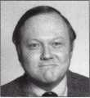

Donald B. Dennis, CPL has been dealing with the  
Locksmithing profession since 1972 with a four year  
apprenticeship in Albuquerque, New Mexico. He founded  
and has been the owner of Dennis Safe & Lock in Johnson  
City, Tennessee since 1977. He was the founder of the  
East Tennessee Locksmith Association in 1988 and is  
currently the Chairman of the Education Committee and  
editor of ETLA Newsletter.

I Sal Dulcamara, CML. has been in the

mTjM locksmith business for over 23 years. He is the president of All Pro Security, Inc. in Michigan and has been an ALOA member

1 for 18 years. A past president of the

Locksmith Security Association of Michigan. Sal currently serves as editor of the association newsletter.

He was named “Keynotes Author of the Year” for 1996 and 1997. He is also a contributing editor for Keynotes.



Tim McMullen oversees legislative affairs for ALOA. He is a graduate of the District of Columbia School of Law and has an extensive background in legislative work.

Keynotes

June 2000

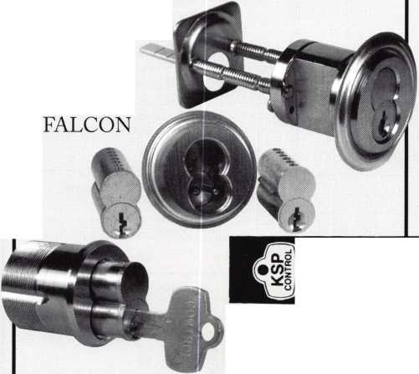

YOUR VIEW OF

SAFE TECHNOLOGY

A WHOLE NEW SHAPE

IN ST. LOUIS

**The Ultimate Trip...for Safe Technicians.**

Unlocking impenetrable monoliths is no mystery to you—you've been doing that your entire career. You've also witnessed your industry in a constant state of evolution.

To keep up with "what's out there" attend SAFETECH 2001 in St. Louis. You'll appreciate the location—in one of America's most modernized cities, and the opportunity to explore the modernization of your industry. For more information call 214.827.7233, or email [convtion@anet-dfw.com](mailto:convtion@anet-dfw.com). SAFETECH 2001-^Shaping the future.

SAFETECH

**2001**

A SAFE ODYSSEY

ST. LOUIS, MO MAY 1-6



Las Vegas is

waiting for gou!

*>MI

m

The 21st Century has arrived. That means it’s time to  
start looking toward the ALOA Security Expo in Las Vegas,  
NV, July 24-30, 2000. ALOA 2000 is the first ALOA  
convention and trade show of the 21st century and it is  
going to be something special. If ever there was a time to  
attend an ALOA convention, it’s this year.

There are new and exciting things to experience at this year’s  
show. Lrom new tools, hardware, software, eight new highly  
informative classes, $1000 Give Away, and a live auction just  
to get you started.

That’s right, free money and a live auction. Lor the first  
time ever, ALOA will be giving away $1,000 per hour the  
last day of the trade show, Sunday, July 30, 2000. All you  
have to do is be a registered attendee and on the show floor  
when your ticket is drawn. After being in Vegas all week,  
who won’t need cash to get them home?

Also new this year, a live auction to be held in conjunction  
with one of the major social events of the week, the annual  
Kick-off Party. Look in the next issue of Keynotes for a list  
of items to be auctioned. This year’s Kick-off Party will  
be sponsored by the ALOA Scholarship Loundation and  
promises to be a first-class event that will set the tone for  
the trade show to follow.

The location, the Las Vegas Hilton, located in the heart  
of Las Vegas and conveniently attached to the convention  
center, is the home of ALOA 2000. There couldn’t be a better  
place to kick off the new century. See you in Las Vegas!

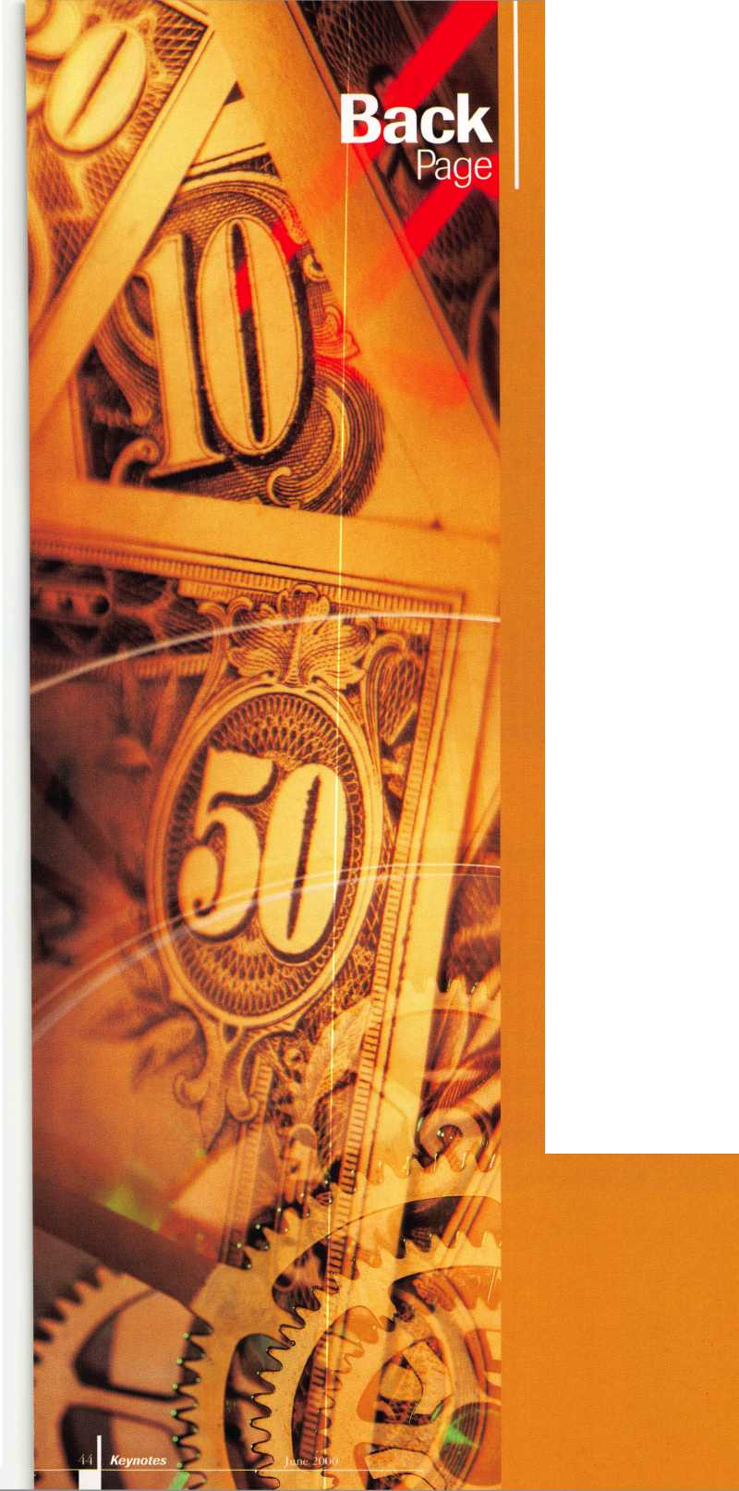

M

*Visit our Website on  
www. stamcctv. com*

THE COMPLETE

CCTV PROGRAM ON CD-ROM  
FOR STAFF TRAINING AND

PRODUCTIVITY ENHANCEMEN

STAM Insight has been  
developed to enhance CCTV  
skills and productivity with  
many different uses.

Productivity

System Drawing Hi Estimation • CCTV Training H CCTV Reference HI Sales/Demo System Design Hi Staff Evaluation

CCTV Content

CCTV Calculators

Demonstration Tool

Estimation

Drawing

Internet Enabled

sii

Pre-Test

I\£k Knowledge Assessment

**Sold in Over 50 Countries**



Distributed by:



EH Yes, please send me a FREE PREVIEW CD ROM - Send $9.95 Shipping and Handling

Name:

Job Title:

Organisation:

Address:

.Zip/Postcode.

..e-mail.

Fax: ( )

COPYRIGHT © 1996 Security Training and Marketing Pty Ltd. All rights reserved ACN 057 006 541

Country

Tel: ( )

